**Andrew NG- Machine Learning**

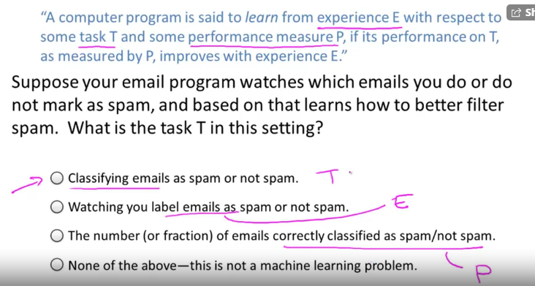

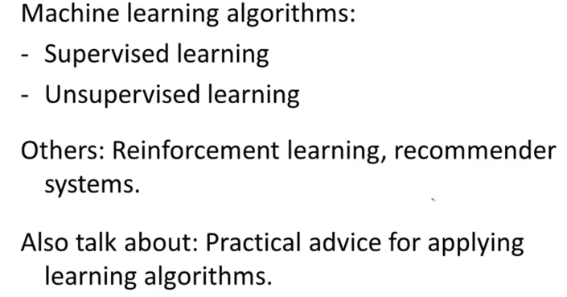

What is Machine Learning?

What is Machine Learning?

Two definitions of Machine Learning are offered. Arthur Samuel described it as: "the field of study that gives computers the ability to learn without being explicitly programmed." This is an older, informal definition.

Tom Mitchell provides a more modern definition: "A computer program is said to learn from experience E with respect to some class of tasks T and performance measure P, if its performance at tasks in T, as measured by P, improves with experience E."

Example: playing checkers.

E = the experience of playing many games of checkers

T = the task of playing checkers.

P = the probability that the program will win the next game.

In general, any machine learning problem can be assigned to one of two broad classifications:

Supervised learning and Unsupervised learning.

**Supervised Learning:**

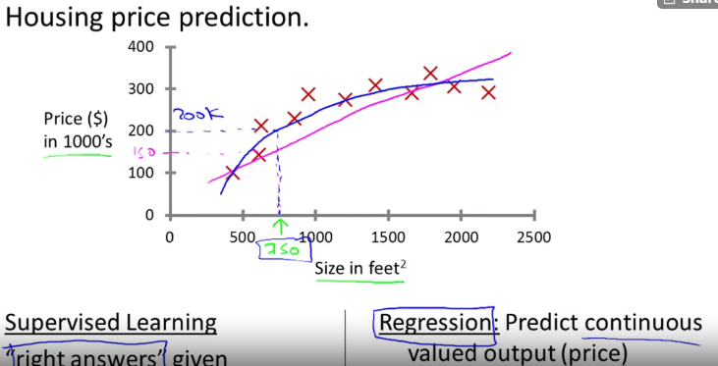

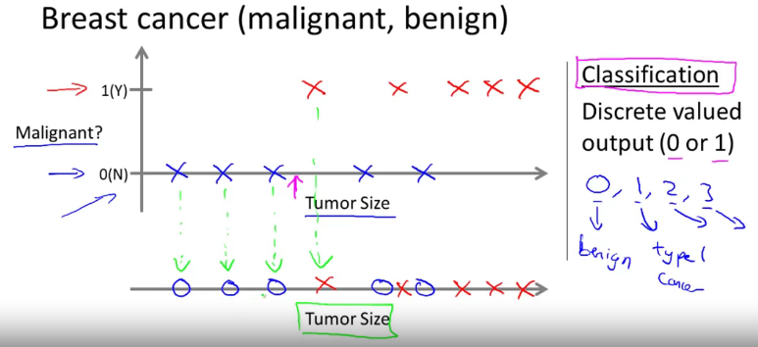

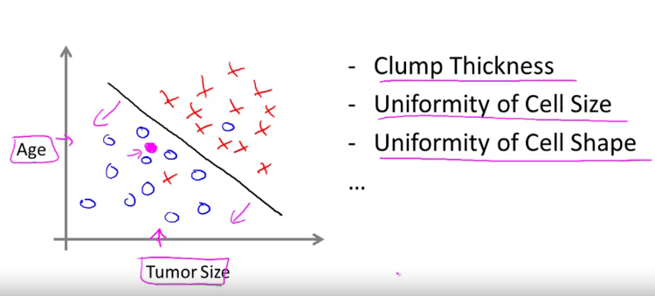

## Supervised Learning

In supervised learning, we are given a data set and already know what our correct output should look like, having the idea that there is a relationship between the input and the output.

Supervised learning problems are categorized into "regression" and "classification" problems. In a regression problem, we are trying to predict results within a continuous output, meaning that we are trying to map input variables to some continuous function. In a classification problem, we are instead trying to predict results in a discrete output. In other words, we are trying to map input variables into discrete categories.

**Example 1:**

Given data about the size of houses on the real estate market, try to predict their price. Price as a function of size is a continuous output, so this is a regression problem.

We could turn this example into a classification problem by instead making our output about whether the house "sells for more or less than the asking price." Here we are classifying the houses based on price into two discrete categories.

**Example 2**:

(a) Regression - Given a picture of a person, we have to predict their age on the basis of the given picture

(b) Classification - Given a patient with a tumor, we have to predict whether the tumor is malignant or benign.

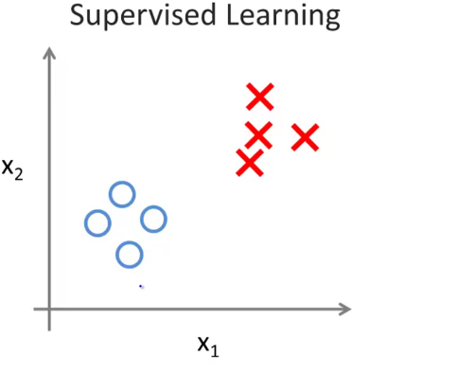

No labels🡪 unsupervised

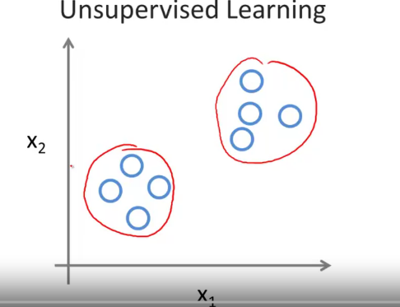

Clustering (Unsupervised) 🡪 Searching news in google, so that relevant news we will get

**Applications of Clustering:**

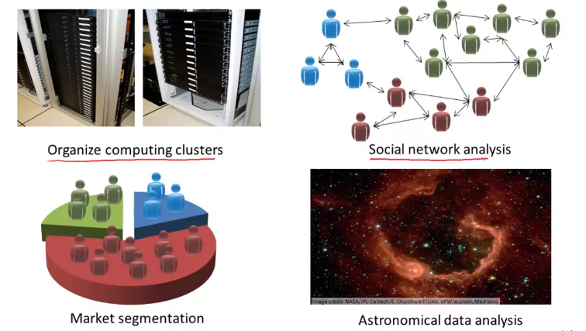

Unsupervised Learning

Unsupervised Learning

Unsupervised learning allows us to approach problems with little or no idea what our results should look like. We can derive structure from data where we don't necessarily know the effect of the variables.

We can derive this structure by clustering the data based on relationships among the variables in the data.

With unsupervised learning there is no feedback based on the prediction results.

**Example:**

Clustering: Take a collection of 1,000,000 different genes, and find a way to automatically group these genes into groups that are somehow similar or related by different variables, such as lifespan, location, roles, and so on.

Non-clustering: The "Cocktail Party Algorithm", allows you to find structure in a chaotic environment. (i.e. identifying individual voices and music from a mesh of sounds at a [cocktail party](https://en.wikipedia.org/wiki/Cocktail_party_effect)).

**MODEL Representation:**

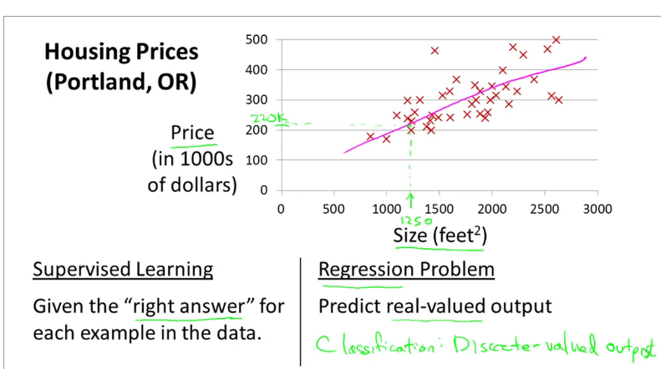

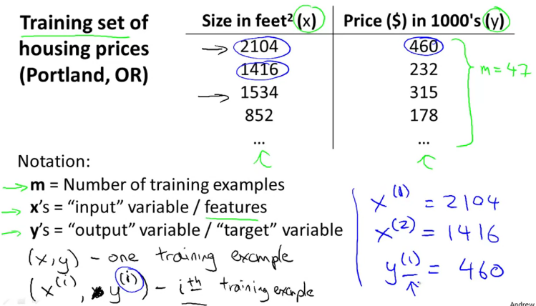

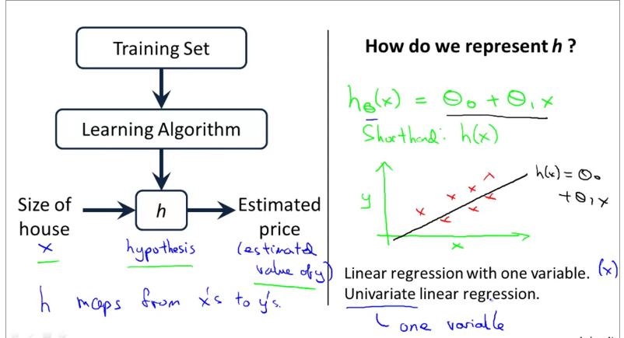

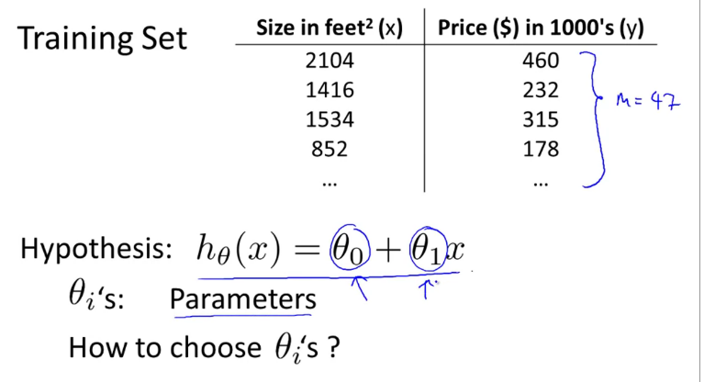

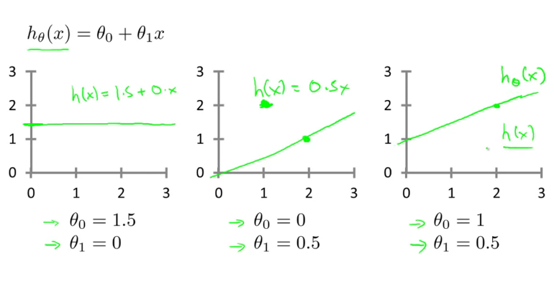

**J🡪 Cost function (or squared error function)**

To find the perfect theta 1 and 2, the cost function J should be minimum, which represents the line is a perfect fit.

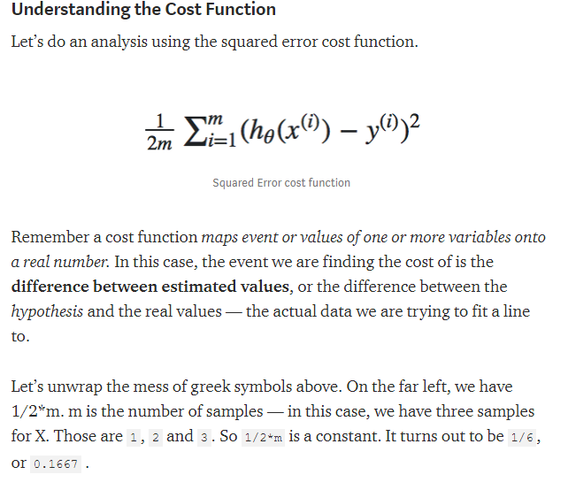

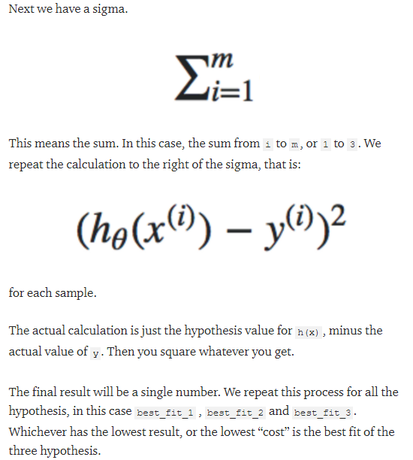

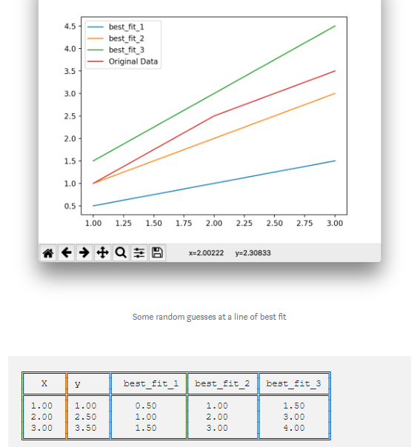

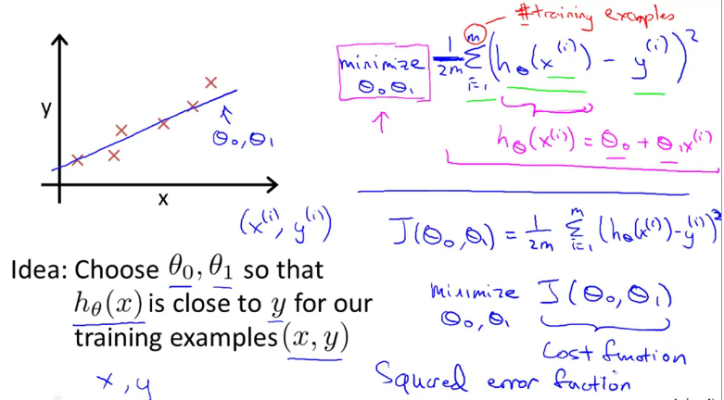

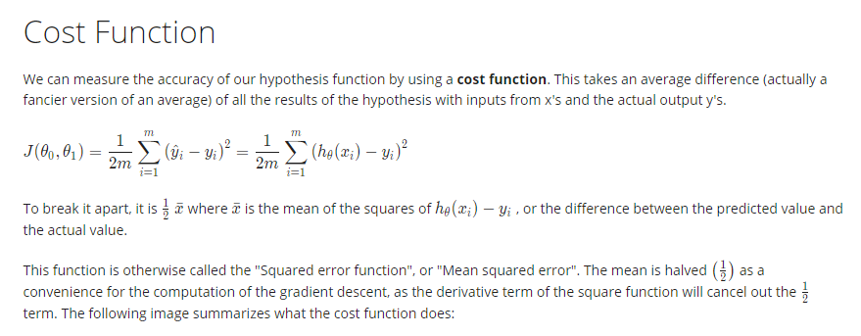

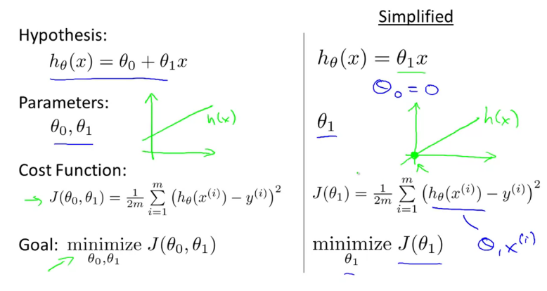

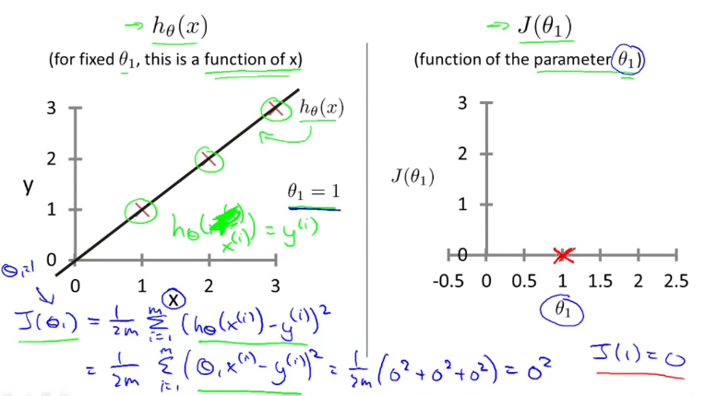

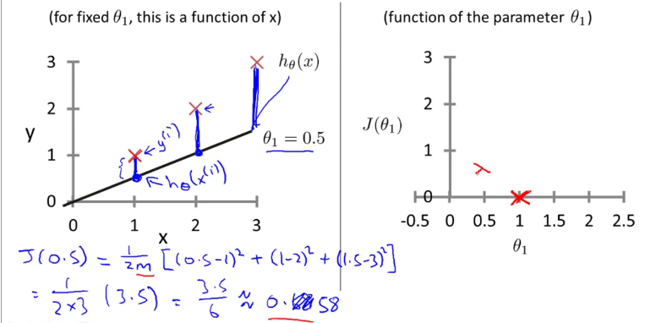

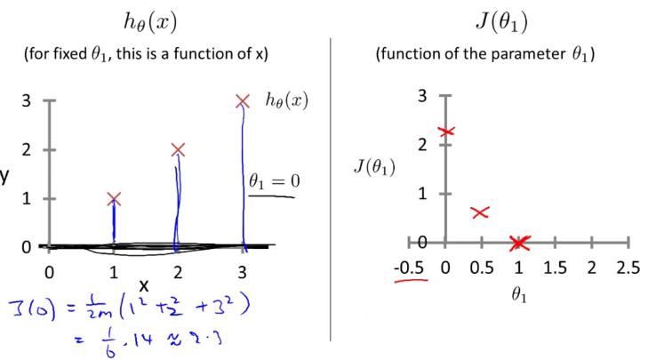

Gradient Descent:

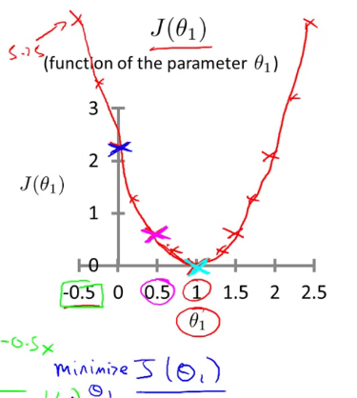

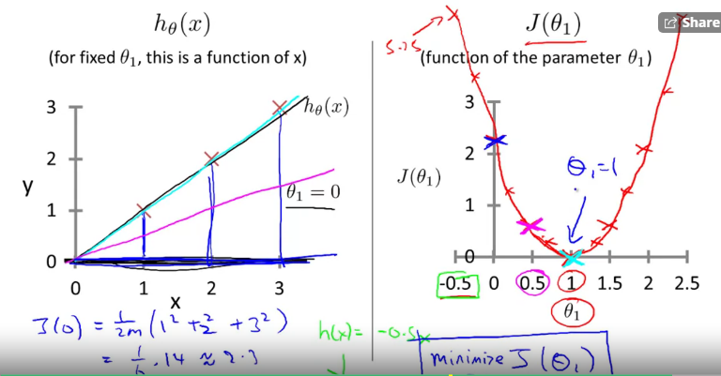

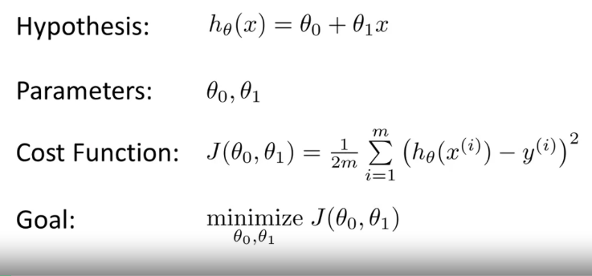

Another Eg:

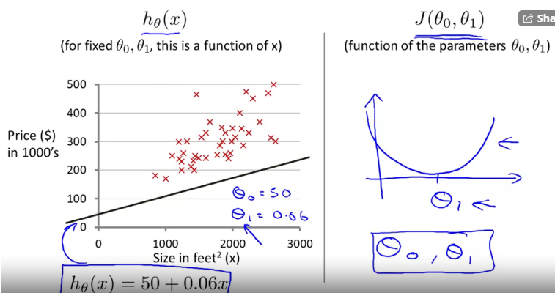

If you have 2 parameters in cost function,

Contours plots/figures:

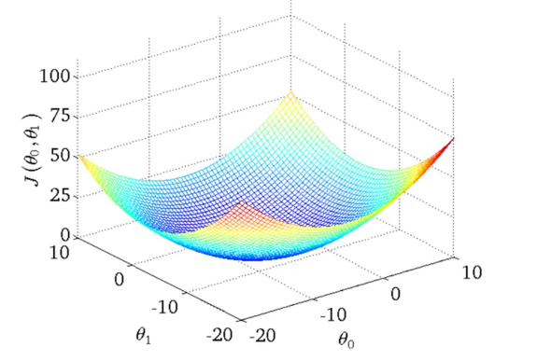

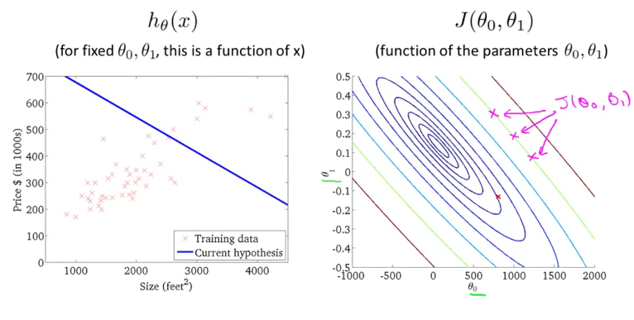

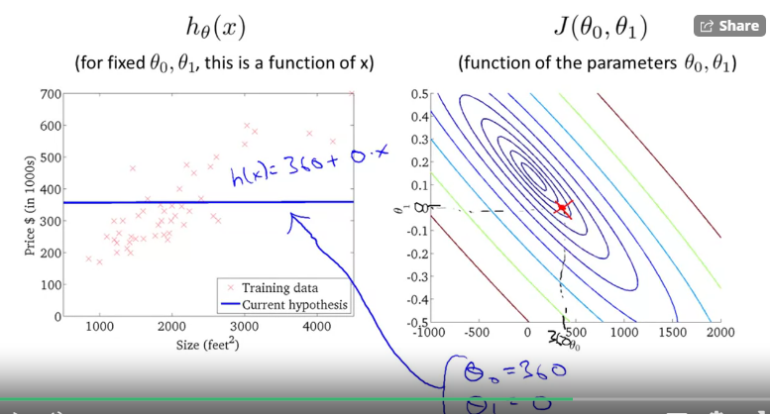

Pretty close to global minimum,

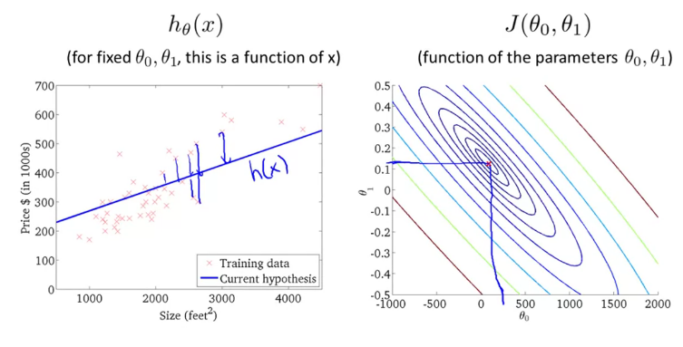

**To minimize the Cost function for theta 1& 2 automatically. We use gradient descent.**

**GRADIENT DESCENT: (**<https://machinelearningmastery.com/linear-regression-tutorial-using-gradient-descent-for-machine-learning/#:~:text=Gradient%20Descent%20is%20the%20process,downhill%20towards%20the%20minimum%20value.>**)**

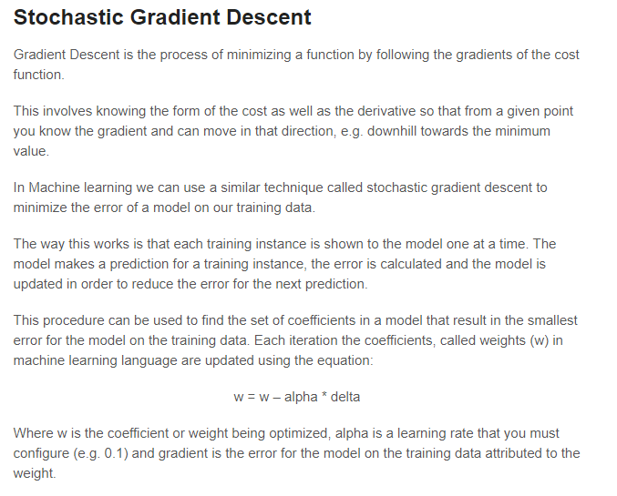

So we have our hypothesis function and we have a way of measuring how well it fits into the data. Now we need to estimate the parameters in the hypothesis function. That's where gradient descent comes in.

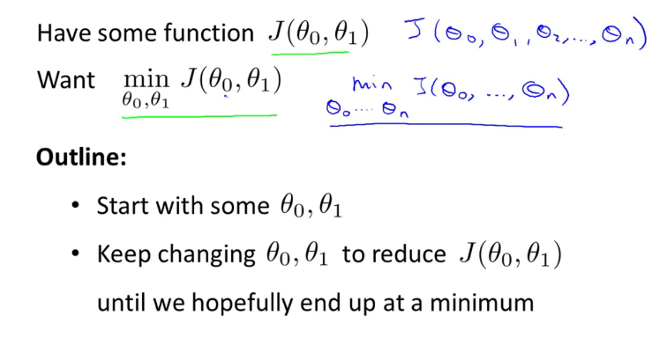

Start with Theta1 and 2 with some value to start.

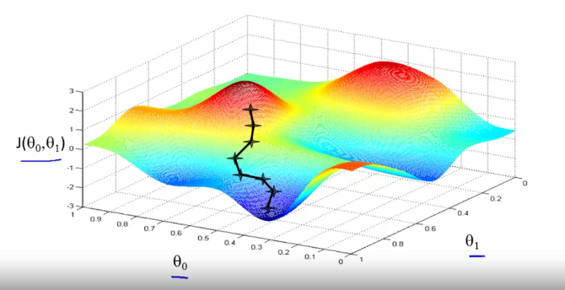

2nd local optimum:

If the initialization is different, it might lead to a different optimum.

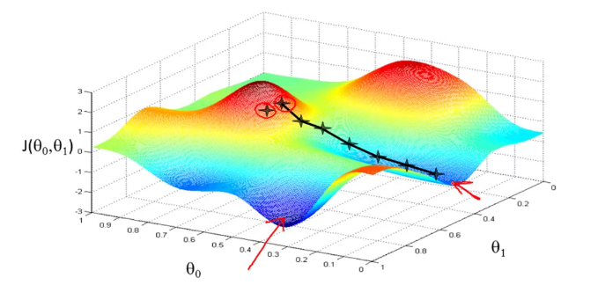

Learning Rate (huge steps if, it is more and baby steps if it is less):

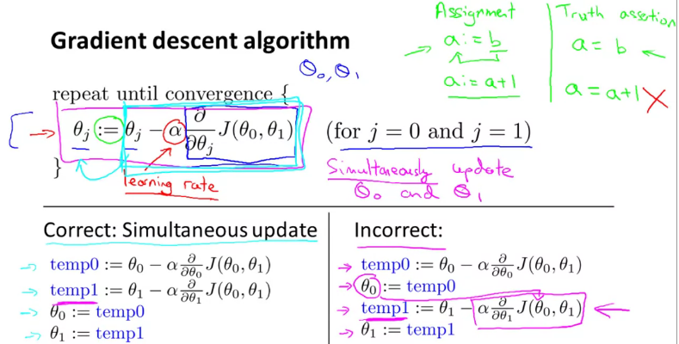

Why gradient Descent simultaneously?

What gradient descent does is look at the point on the surface where you are currently, and finds the quickest route down. This direction is a vector that is a combination of x and y.

When you don't do simultaneous updates, it's like you're taking one step forward (in x), then one step right (in y), then one step forward, then one step right... At each step you're not choosing the steepest descent.

When you update simultaneously, you're combining the two steps into one step that's forward and right at the same time. That's the direction you want to go.

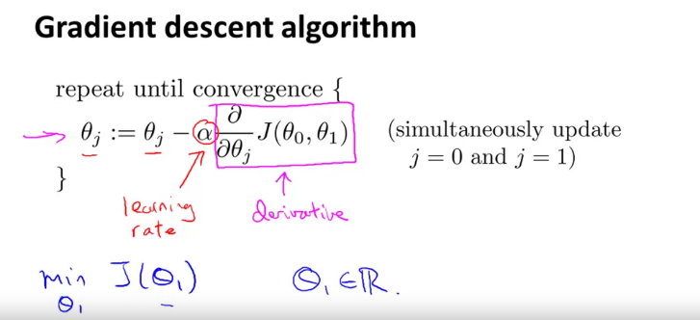

Derivative🡪 it creates a tangent (based on the slope)

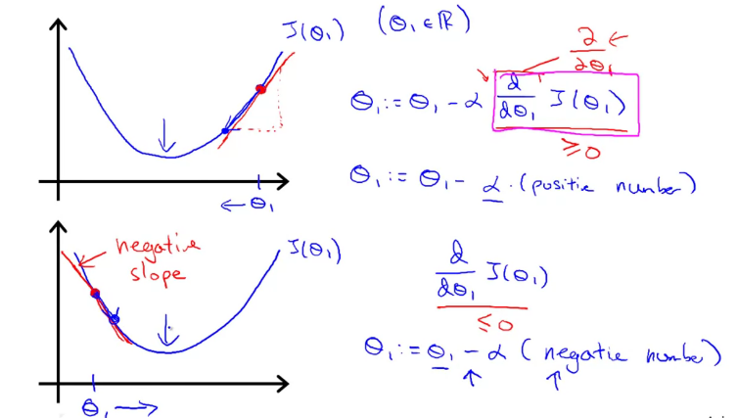

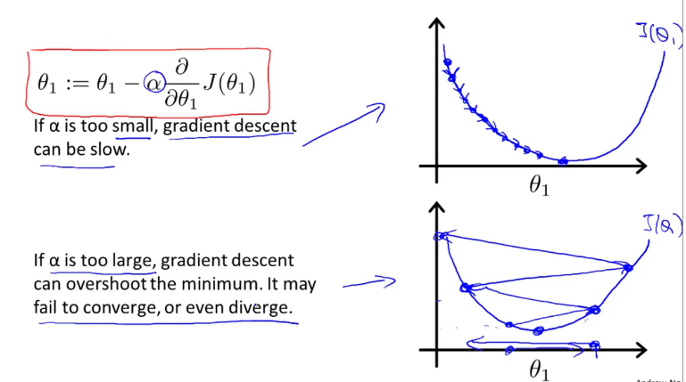

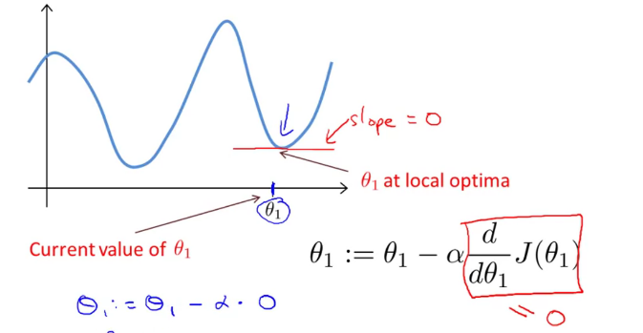

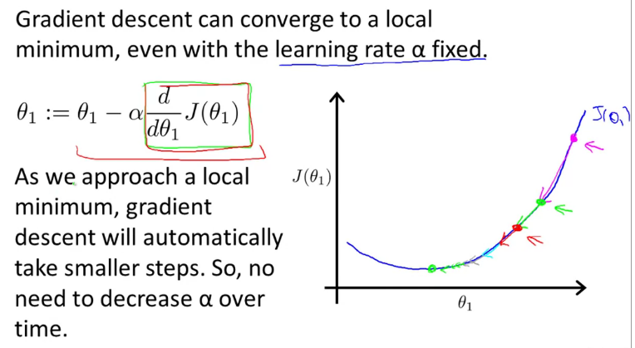

As we approach the local minimum, the derivate will become smaller. At the local minimum, the slope is zero.

**Combining Gradient descent and Linear Regression:**

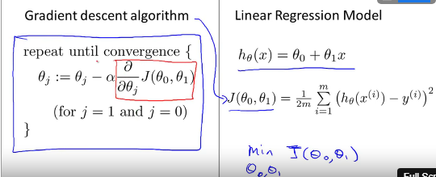

Plug in the value of Cost function,

After the partial differential

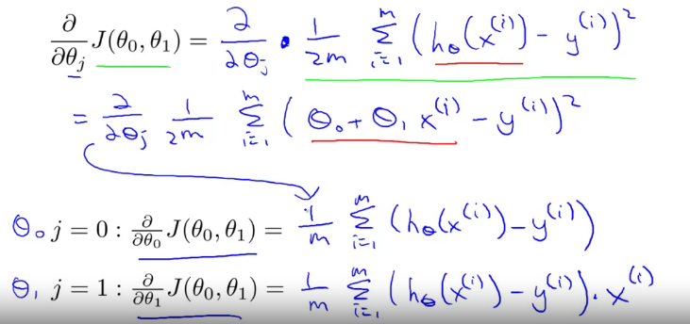

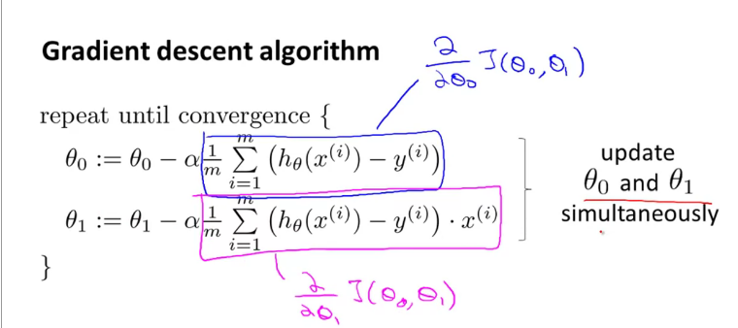

Problem in Gradient Descent is we might end up in local optimum.

In Linear Regression, the cost function is bowl shaped as below, “Convex function”. There is no local optimum. It wil converge to the global optimum.

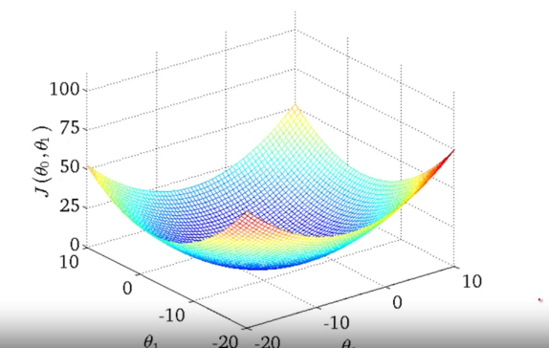

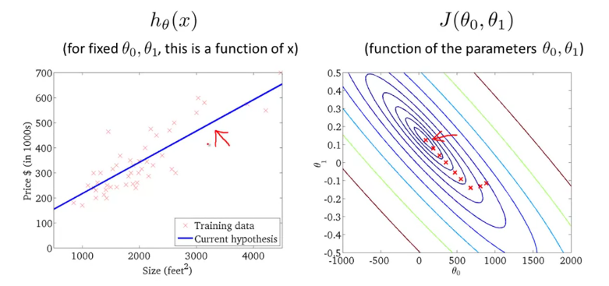

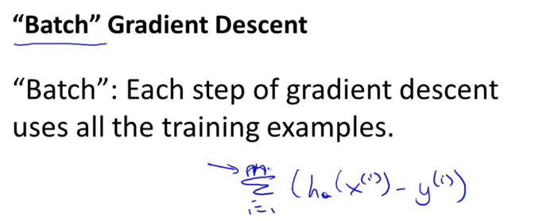

**MULTIPLE FEATURES:**

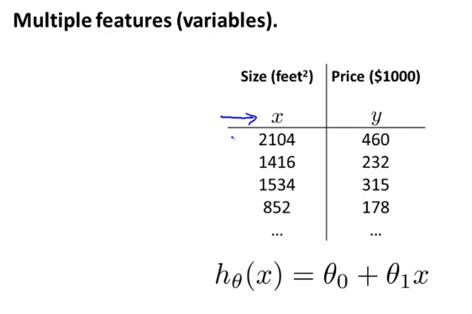

**m🡪 number of rows**

**n🡪 number of columns/features**

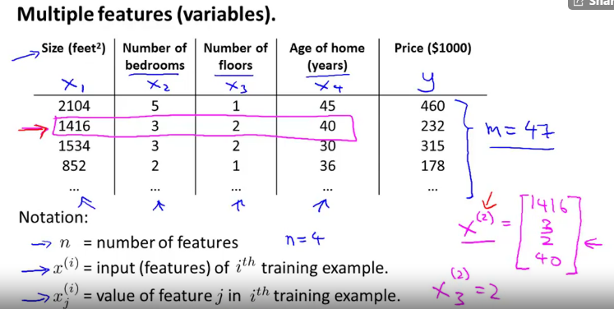

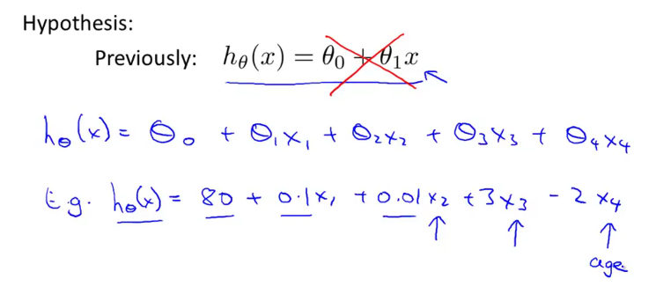

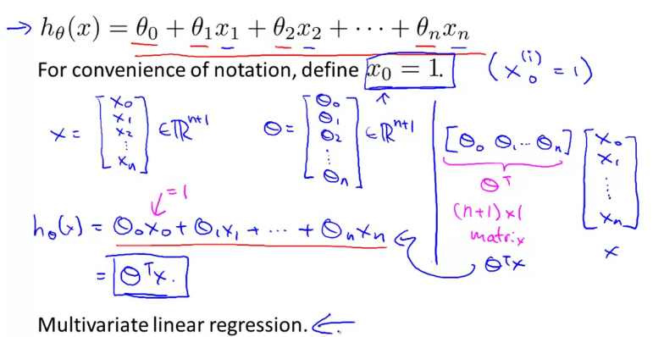

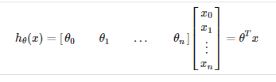

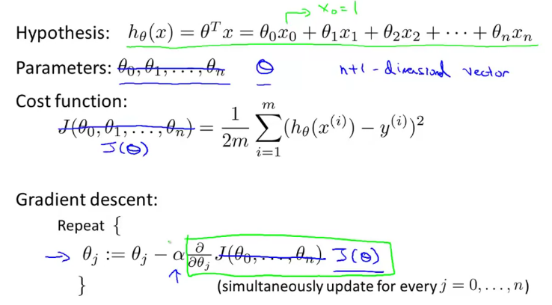

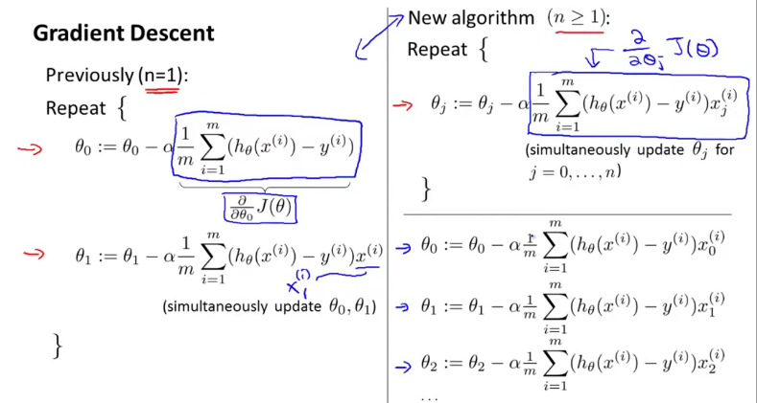

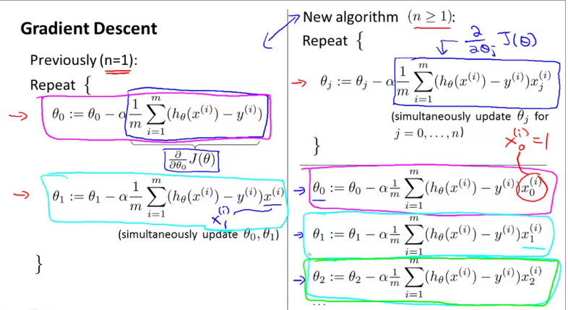

**FEATURE SCALING:**

**If the feature scaling is done, the gradient descent will converge quickly**

**Because, the contours(ellipse) are tall are skewed it will take much time to find the global minimum.**

**See the comparison below, after feature scaling less skewed so that the minimum is found quickly.**

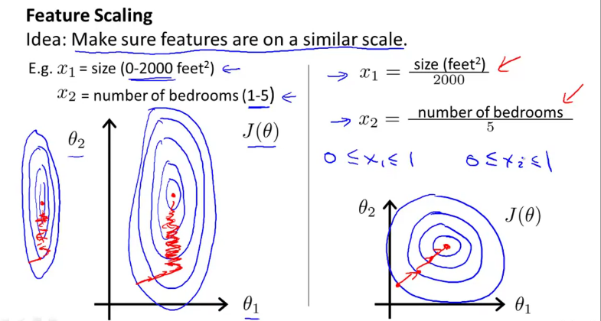

**Points to remembers on feature scaling,**

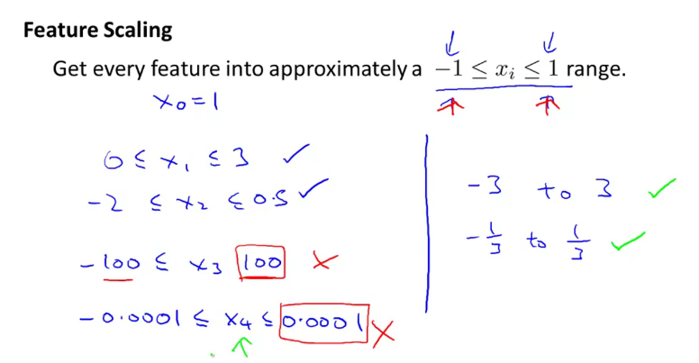

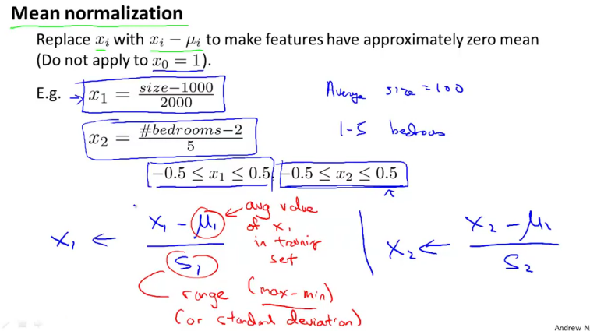

**Average house 🡪1000.**

**To converge Gradient Descent fasters, below techniques are useful.**

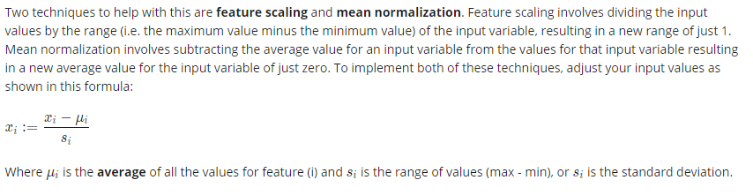

**In 2 ways the gradient descent performance can be increased,**

1. **Feature Scaling/ Mean Normalization**
2. **Learning Rate**

**Plot the cost function with the iteration to find the convergence point.**

**Based on the application the convergence differs (30, 3K, and 300K)**

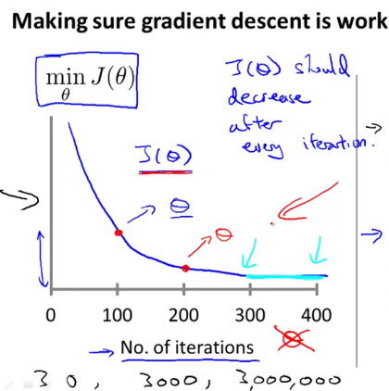

**Below graph shows, the gradient descent not working**

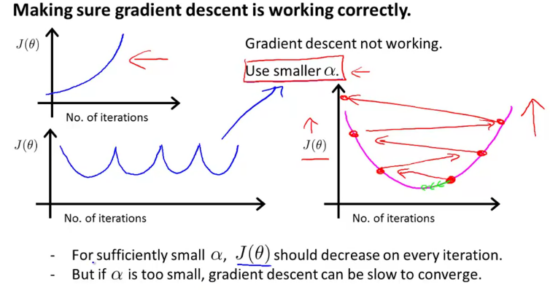

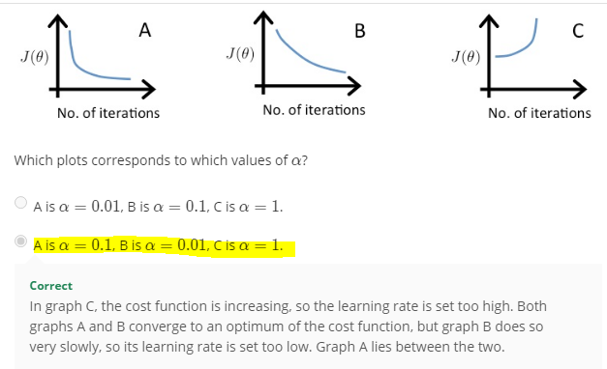

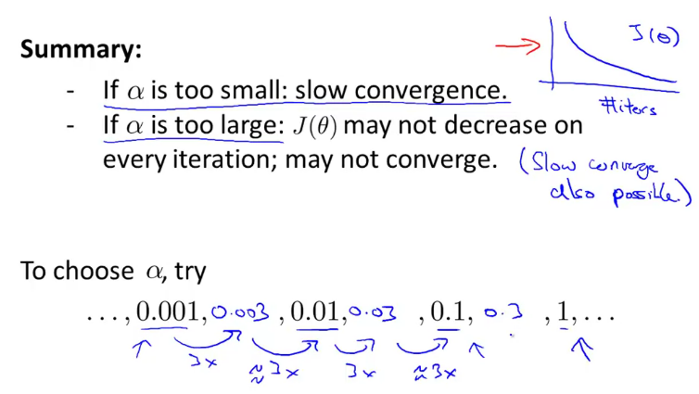

**Deriving new feature for a better model,**

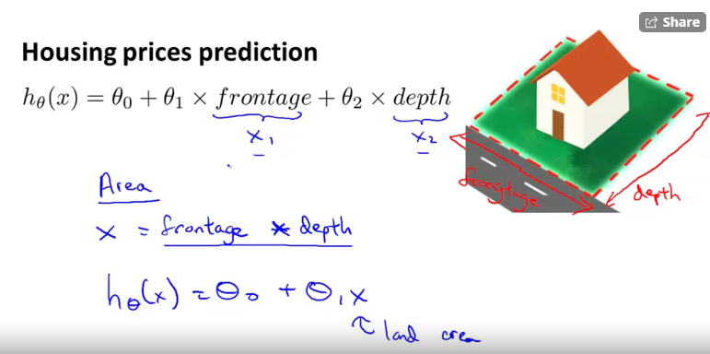

**In polynomial regression, feature scaling is important.**

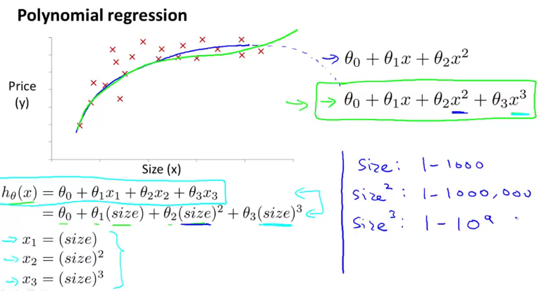

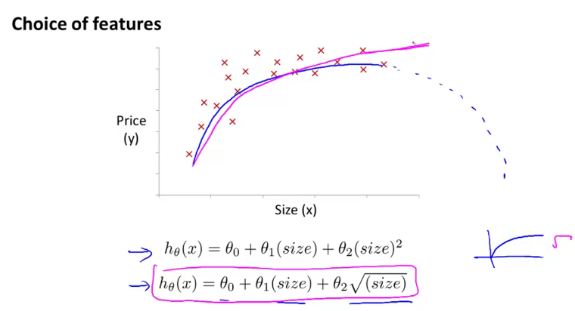

**We can get the solution through,**

1. **Gradient Descent**
2. **Normal Equation**

**Normal Equation:**

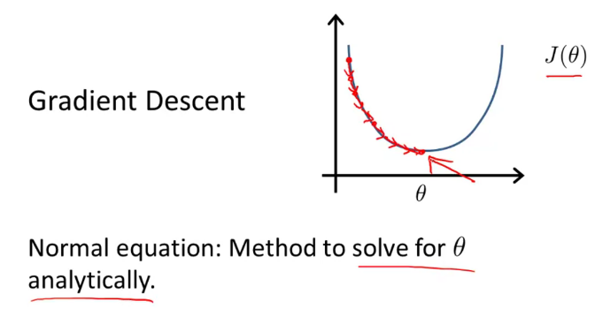

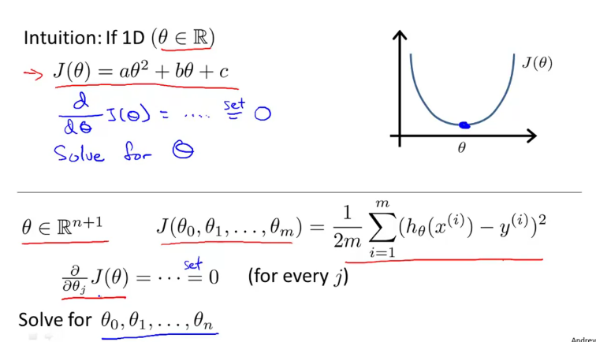

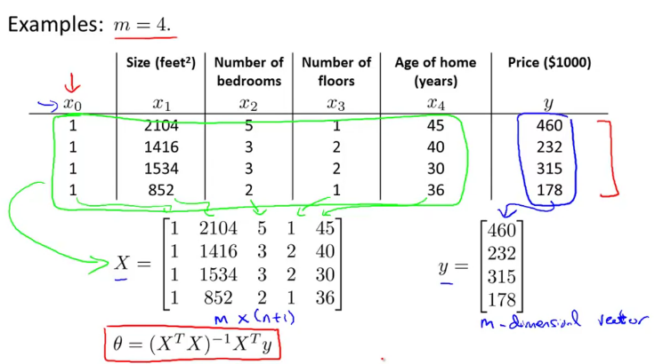

**In Normal Equation solving method, no need of feature scaling.**

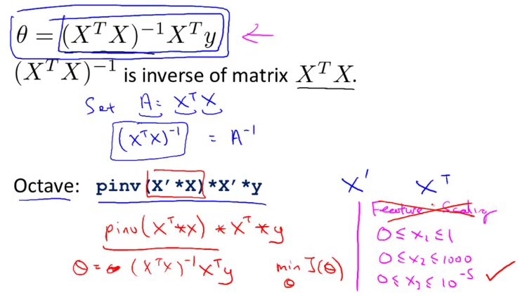

**Gradient Descent vs Normal Equation:**

**Cost of Inversing is costly.**

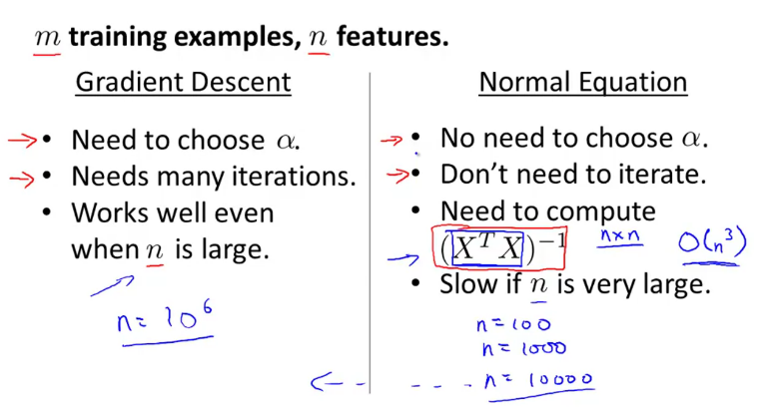

With the normal equation, computing the inversion has complexity O(n^3). So if we have a very large number of features, the normal equation will be slow. In practice, when n exceeds 10,000 it might be a good time to go from a normal solution to an iterative process.

**What is the matrix is non-invertible:**

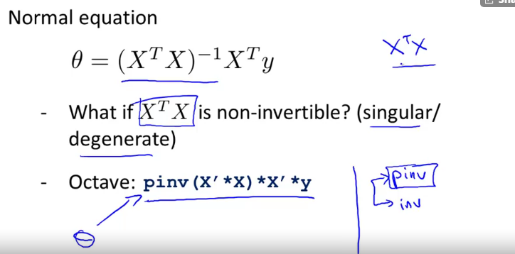

**If we take pseudo Inverse(pinv), then the inverse exists.**

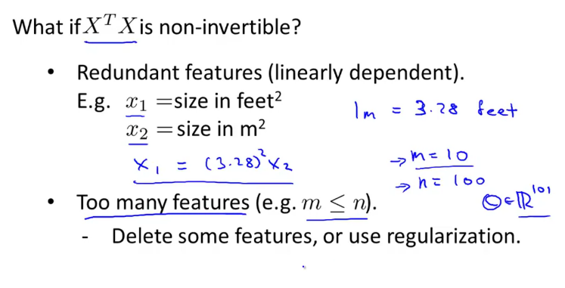

**CLASSIFICATION:**

**EG:**

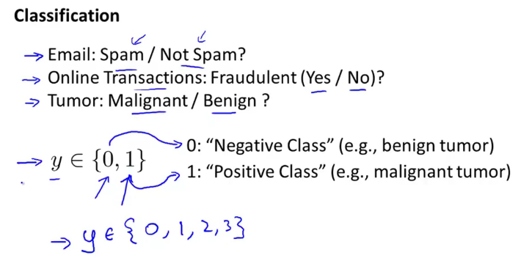

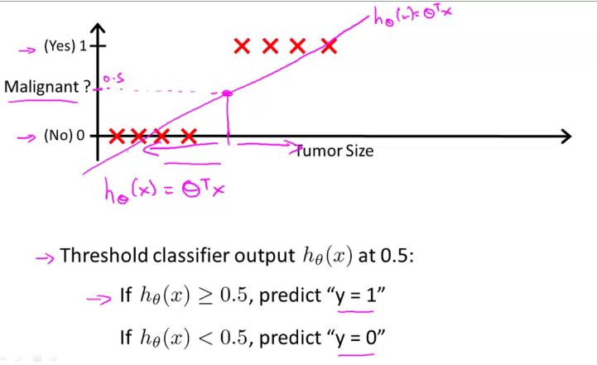

**If there is a point at the end, the linear regression (separating by a line) would be problem.**

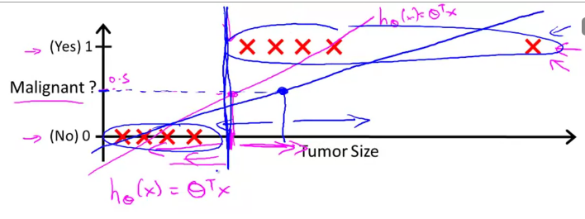

**Hence, using linear regression for a classification problem will not give the best model (hypothesis).**

**In linear regression,**

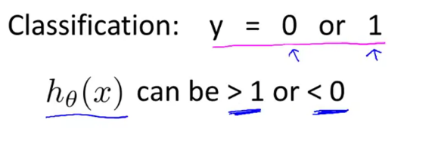

**Hence we use Logistic Regression,**

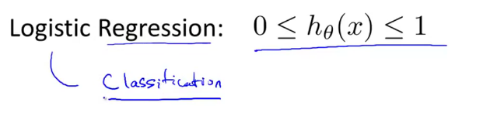

To attempt classification, one method is to use linear regression and map all predictions greater than 0.5 as a 1 and all less than 0.5 as a 0. However, this method doesn't work well because classification is not actually a linear function.

The classification problem is just like the regression problem, except that the values we now want to predict take on only a small number of discrete values. For now, we will focus on the **binary classification** **problem** in which y can take on only two values, 0 and 1. (Most of what we say here will also generalize to the multiple-class case.)

**We use sigmoid function in logistic Regression.**

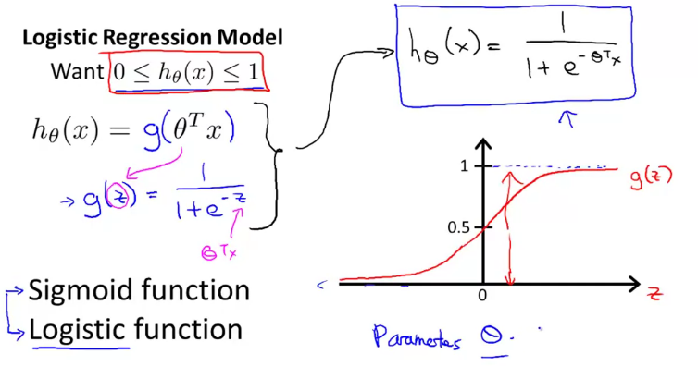

**Using conditional Prob,**

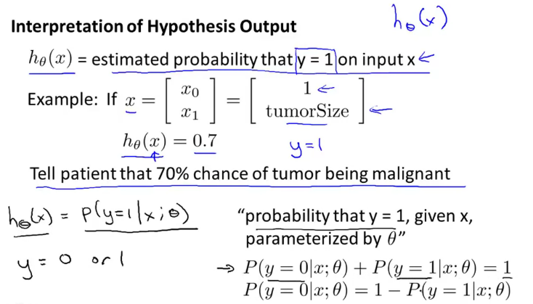

**P (A) +P (B) =1**

**DECISION BOUNDARY:**

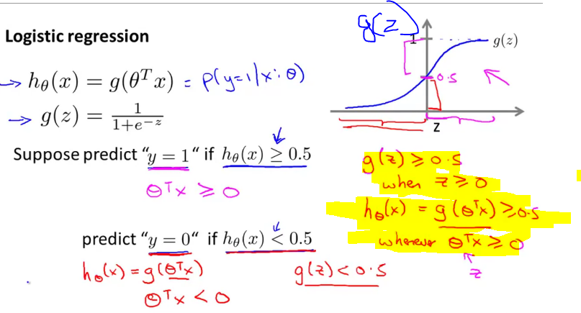

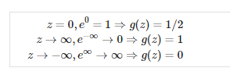

**To draw a line (boundary decision), to predict 1 or 0**

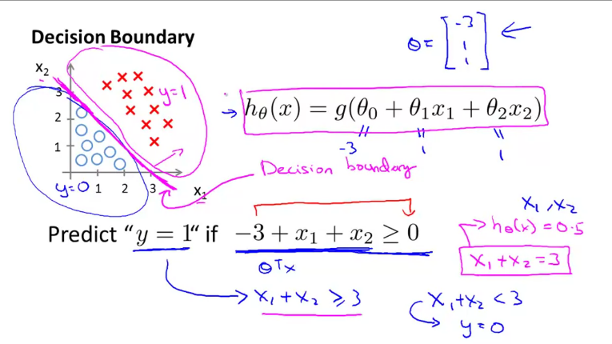

**Final Prediction based on new values:**

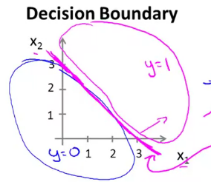

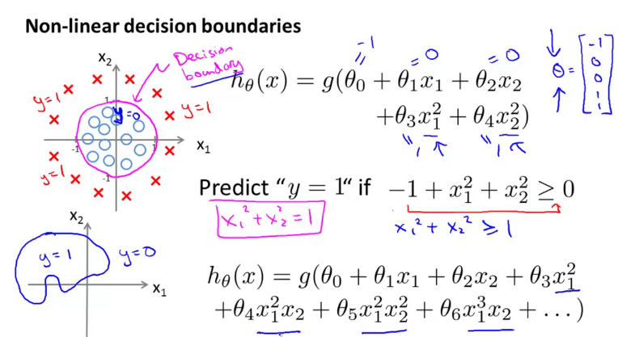

**Cost Function- Logistic Regression:**

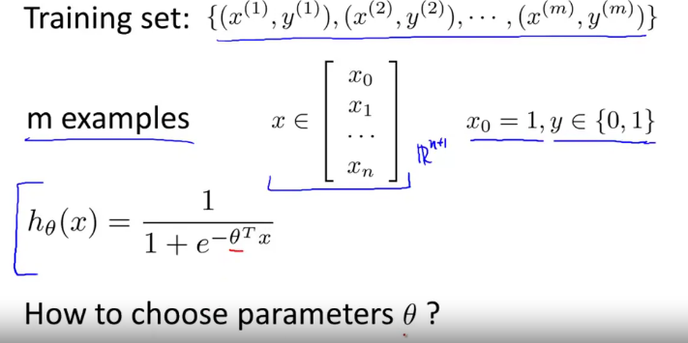

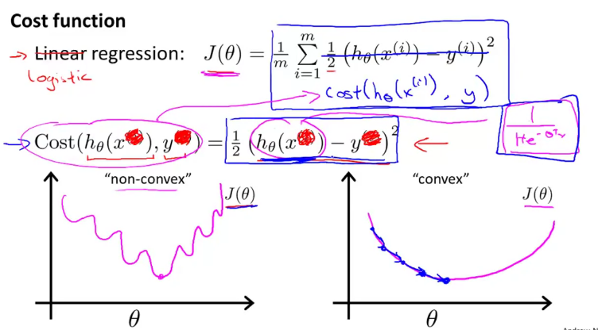

**We are coming up with different cost function since it is non-convex (Use of Sigmoid makes it non convex).**

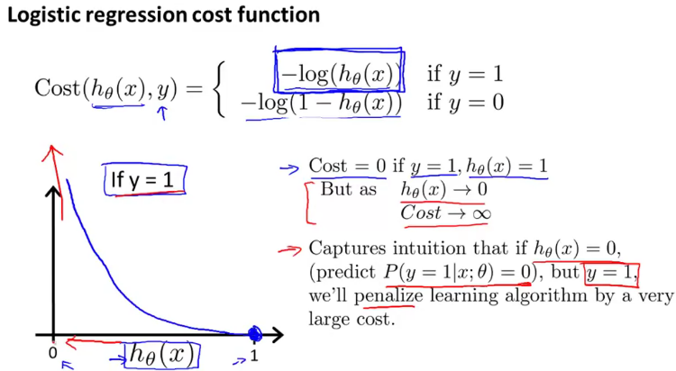

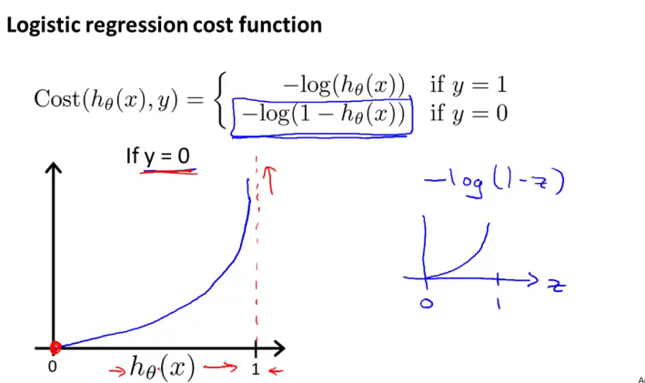

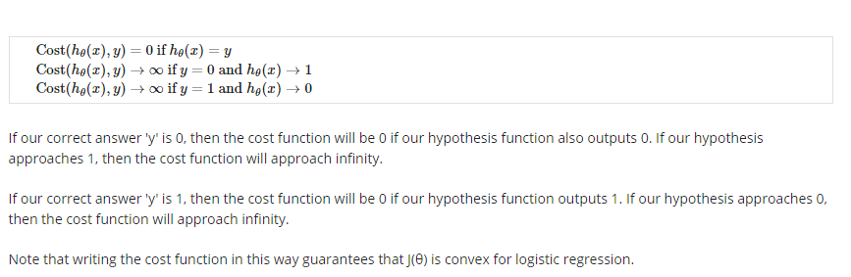

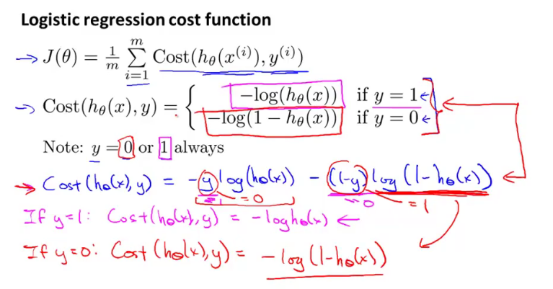

**The main advantages of this cost function is , it provides a convex shape Gradient Descent.**

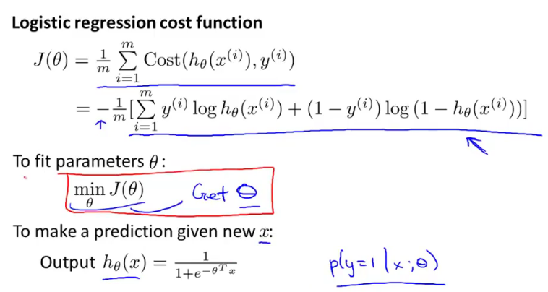

**To minimize the cost function, we use gradient descent.**

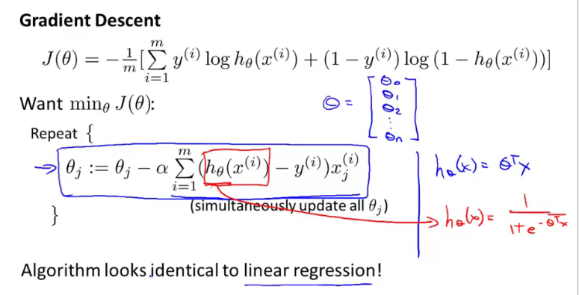

**After partial derivative, the cost function is identical to linear regression.**

**Feature Scaling improves the gradient descent convergence too.**

**Vectorization:**

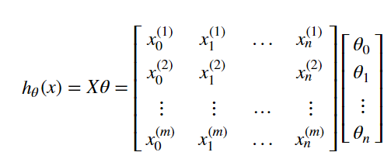

**For reference🡪** <https://towardsdatascience.com/vectorization-implementation-in-machine-learning-ca652920c55d>

Vectorization is fasters compared to for loop.

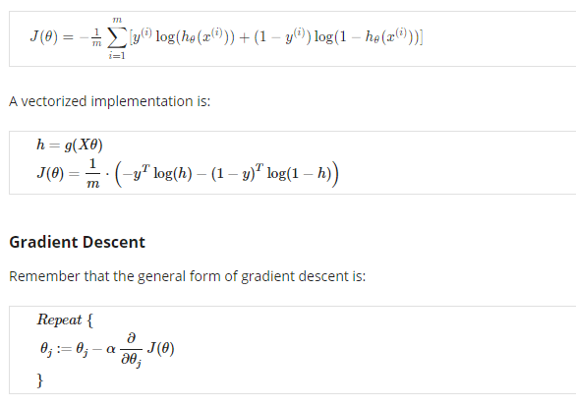

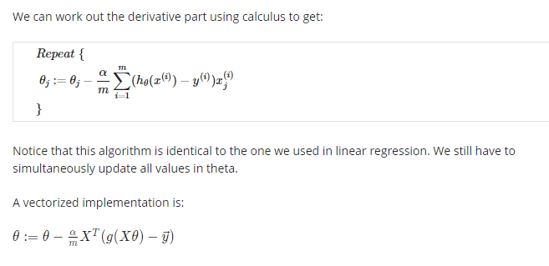

**ADVANCE OPTIMIZATION:**

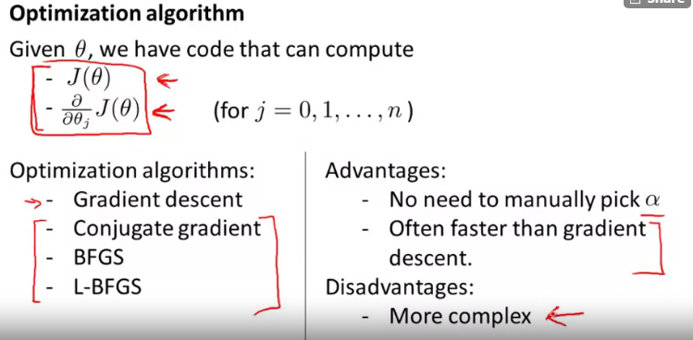

**Multiclass classification:**

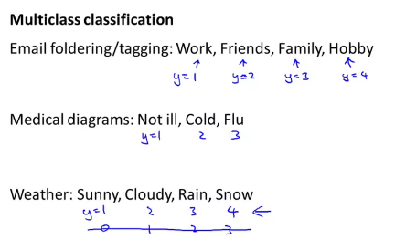

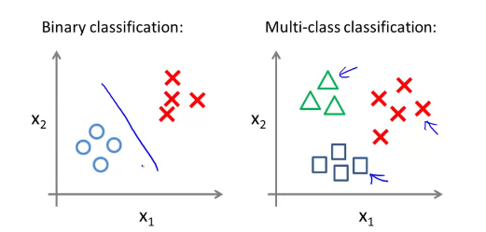

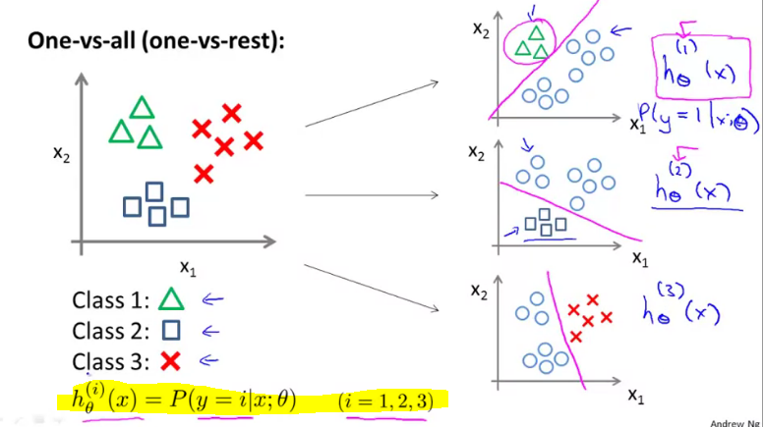

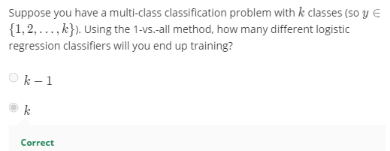

**Regularization: (The problem of overfitting)**

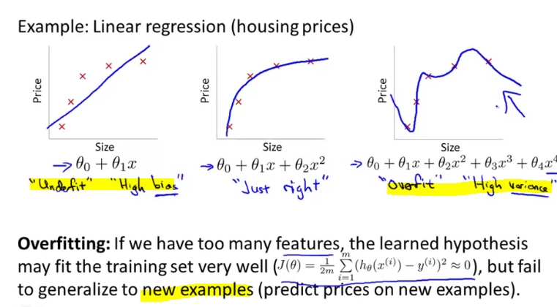

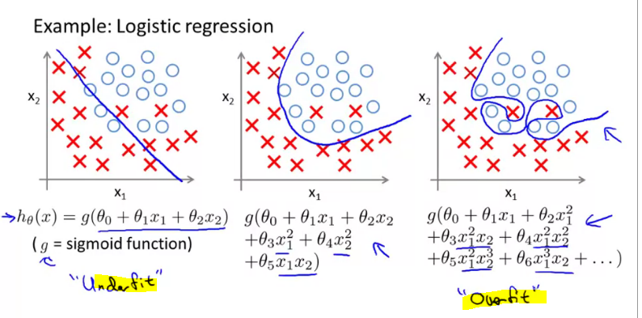

**If we have lot of features, plotting them to identify overfitting would be difficult. Even visualization too.**

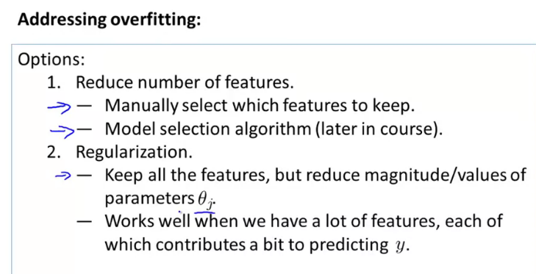

One of the major aspects of training your machine learning model is avoiding overfitting. The model will have a low accuracy if it is overfitting. This happens because your model is trying too hard to capture the noise in your training dataset. **By noise we mean the data points that don’t really represent the true properties of your data, but random chance**. Learning such data points, makes your model more flexible, at the risk of overfitting.

One possible answer is to use **cross-validation**: you divide your training data, you train your model for a fixed value of λ and test it on the remaining subsets and repeat this procedure while varying λ. Then you select the best λ that minimizes your loss function.

**Regularization-Cost Function ()**

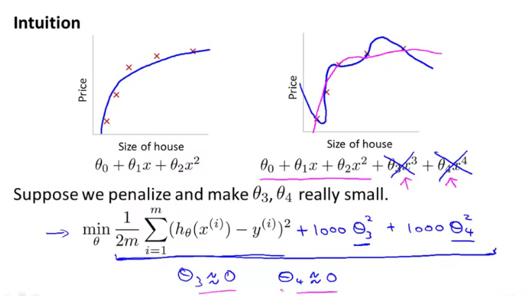

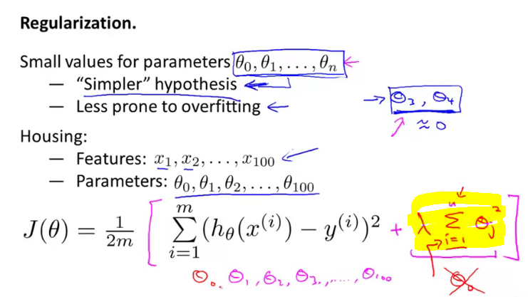

**To keep the parameter small (shrinking the parameter), we add the 2nd part in the cost function.**

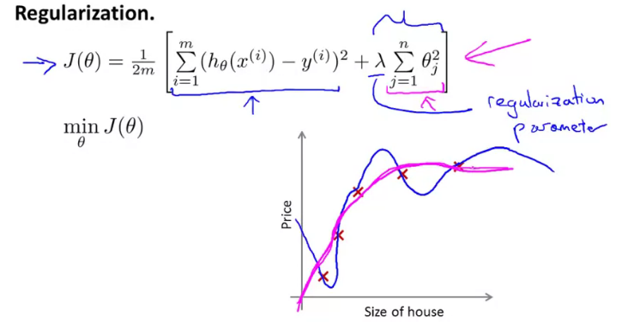

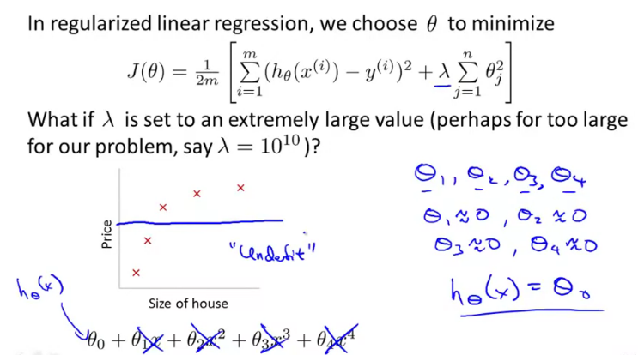

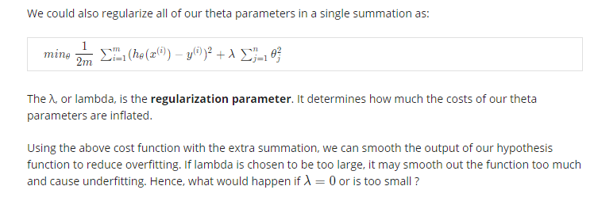

**Regularized Linear Regression:**

**We don’t penalize theta 0,**

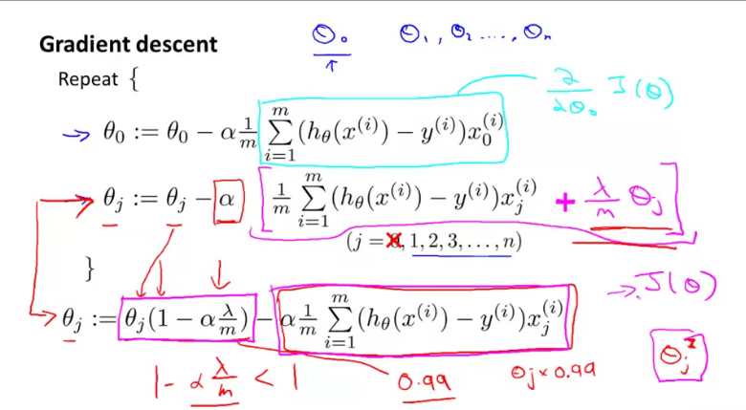

**Regularization for Normal Equation:**

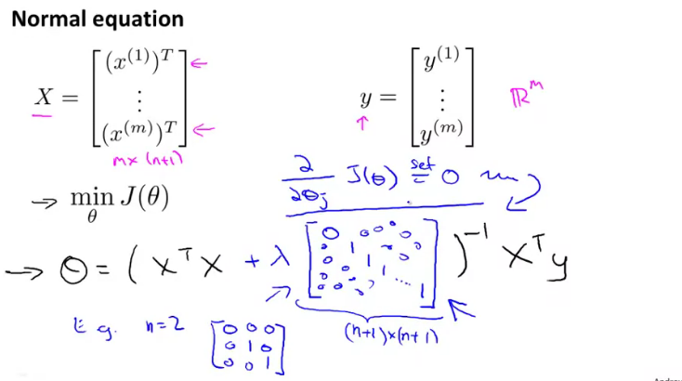

**By Matrix Shifting, the rank will increased (makes it invertible)**

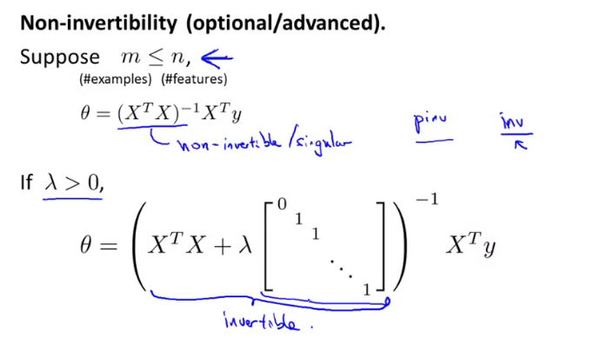

It is said that X is non-invertible if m ≤ n. The correct statement should be that X is non-invertible if m < n, and may be non-invertible if m = n.

**Regularized Logistic Regression:**

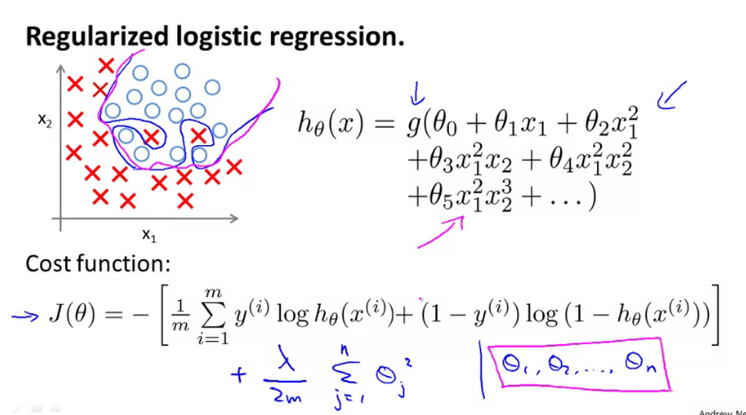

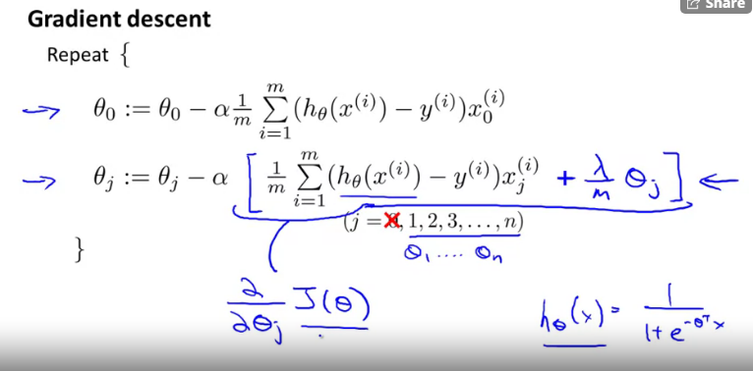

**Neural Network:**

**For 2 – Dimensional (2 Feature), polynomial regression might work for complex non-linear classification. However, as the number of feature grows, it would be complex O (n^2).**

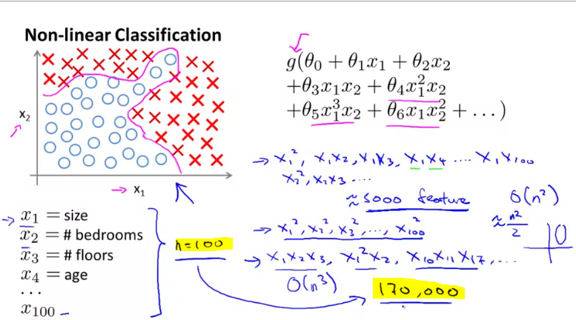

**2 problems:**

1. **Overfitting**
2. **Computationally Complex**

**In Computer vision, the complexity grows.**

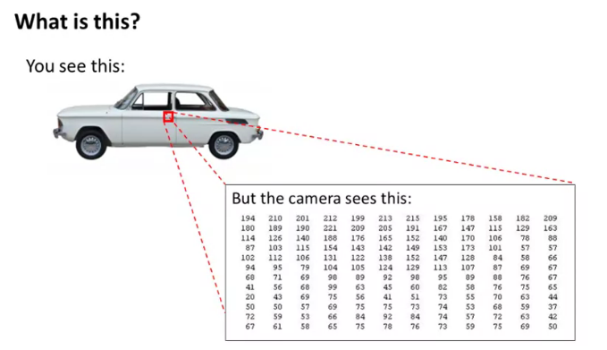

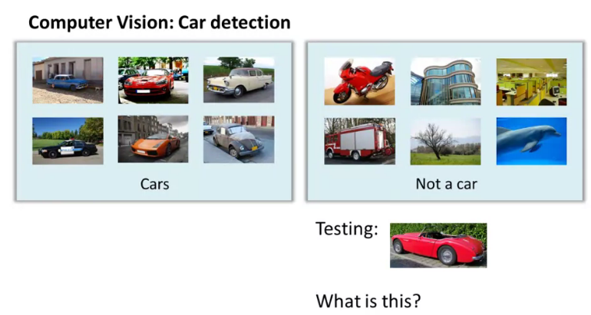

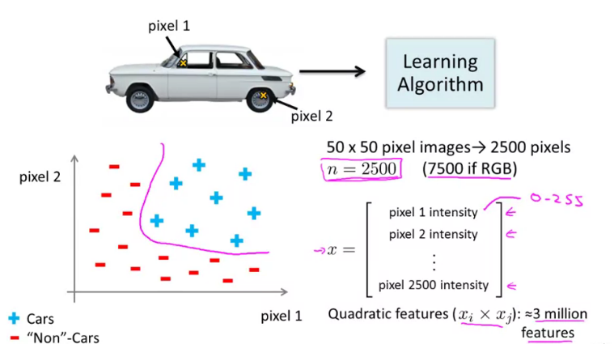

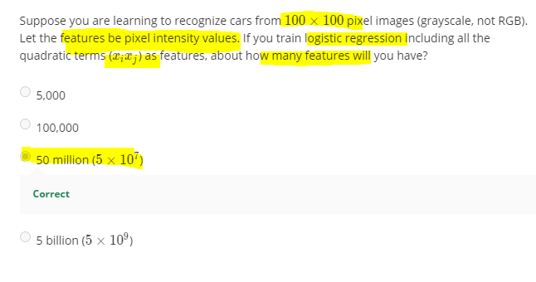

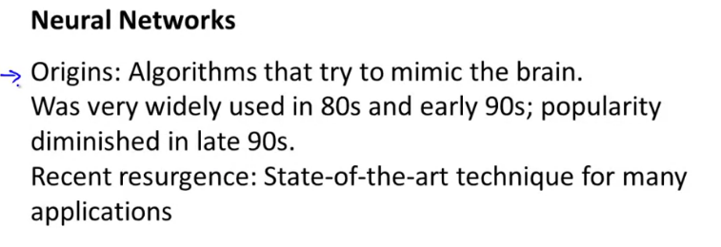

**Diminished Reason:**

1. **Computationally complex in 90’s**

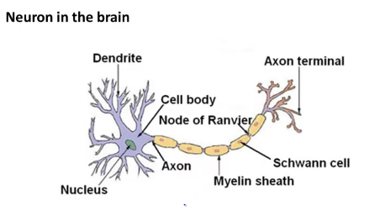

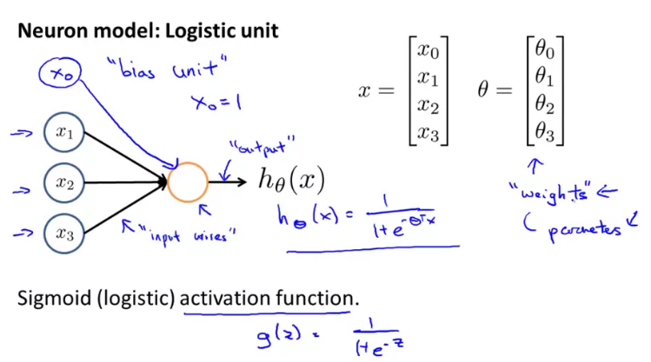

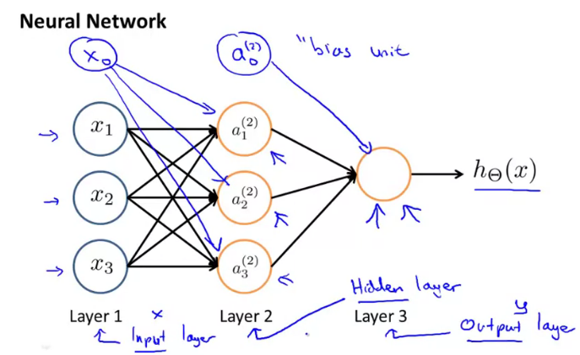

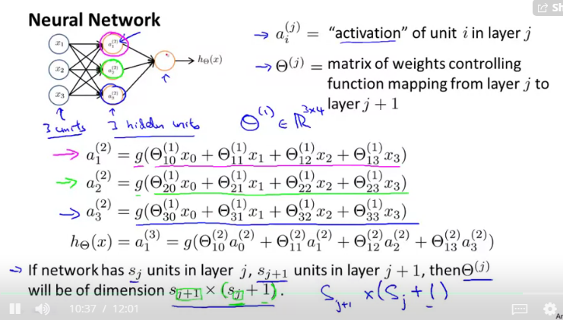



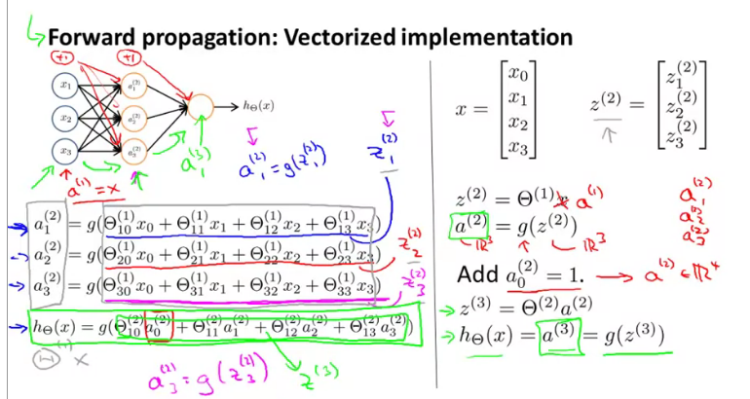

**Vectorization is the effective way of computation.**

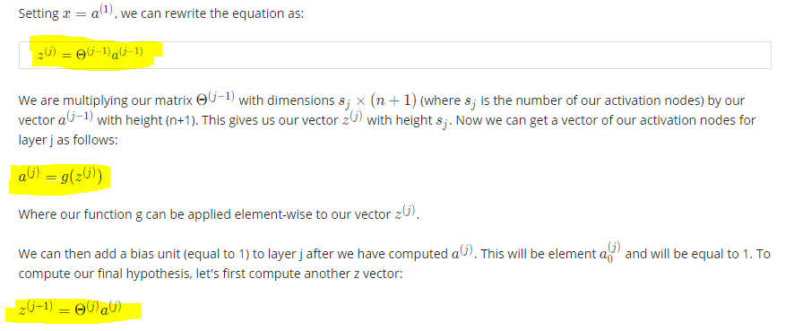

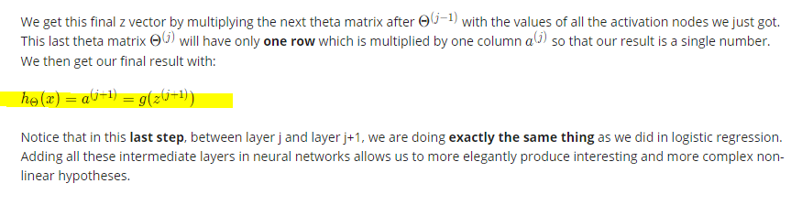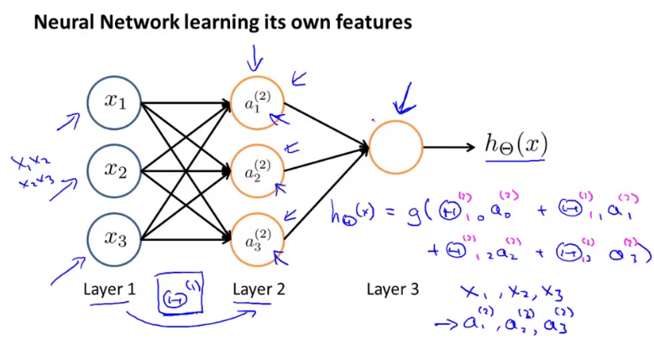

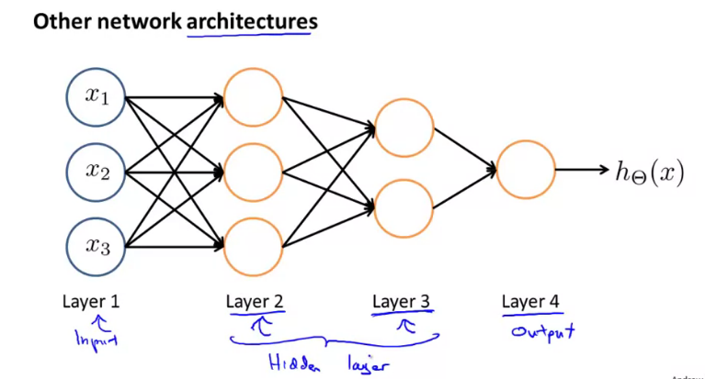

**To catch the complex non-linear hypothesis, hidden layer is useful**

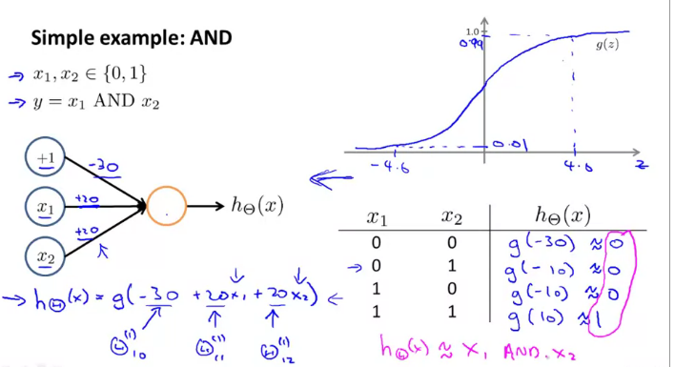

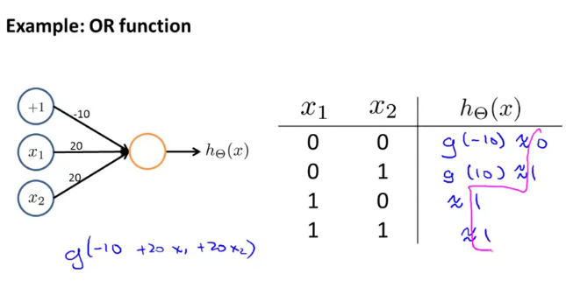

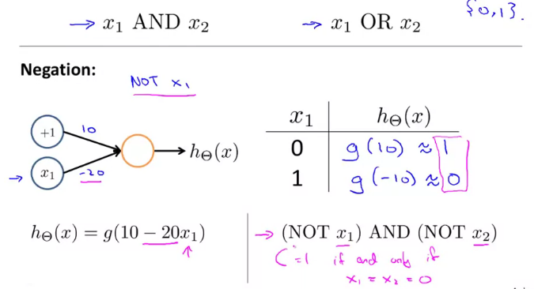

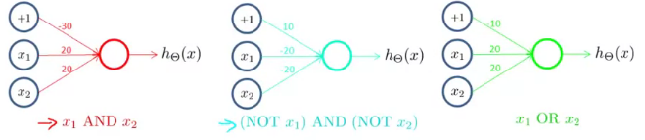

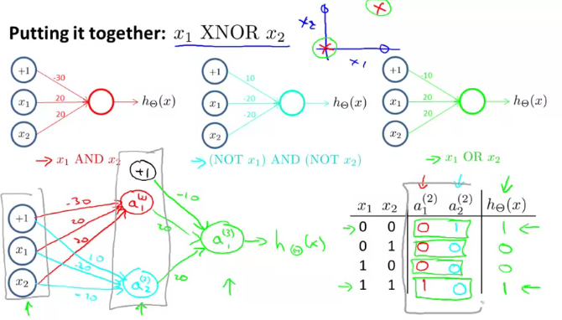

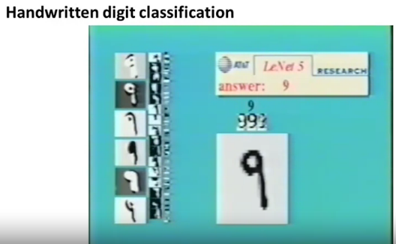

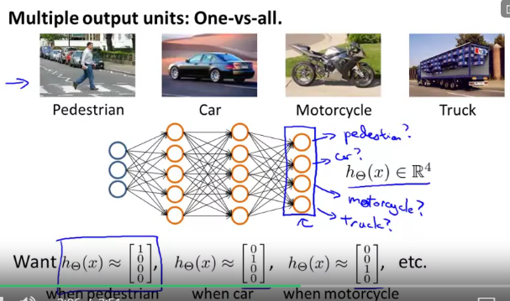

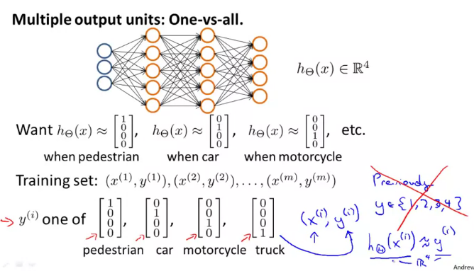

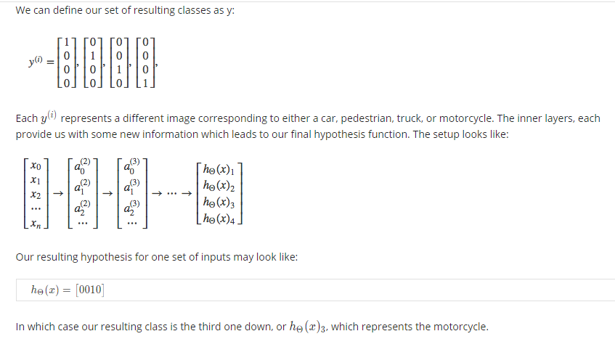

**Cost-Function- Neural Network:**

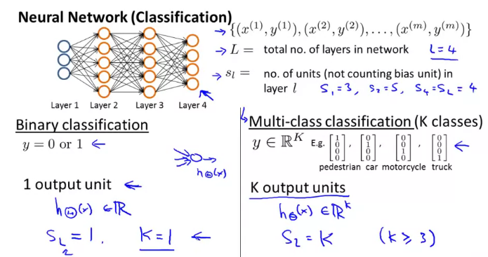

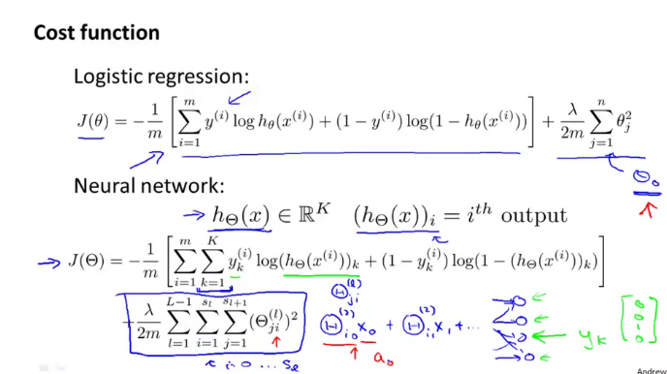

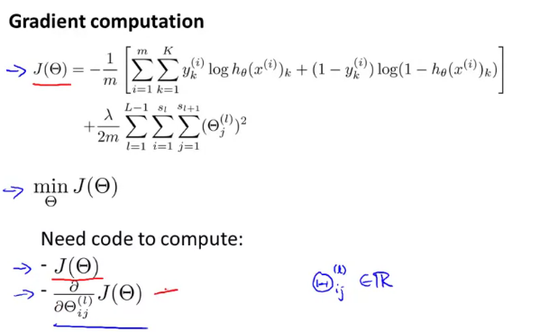

**In neural Network, the gradient descent is computed through forward and backward propagation.**

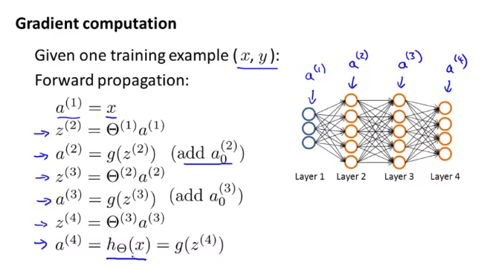

**Delta=”error”, *🡪 element wise multiplication ,g`- derivative**

**No delta 1 because it is the input layers**

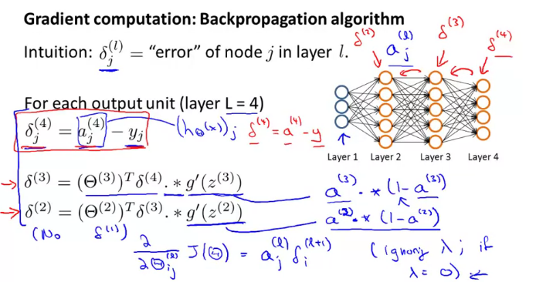

1. **Forward Propagation**
2. **Compare the predicted and actual output**
3. **Do Backward prorogation to find the delta**

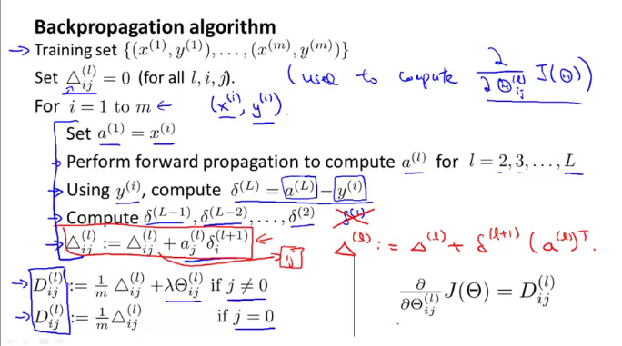

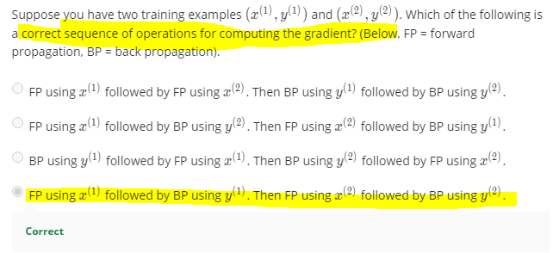

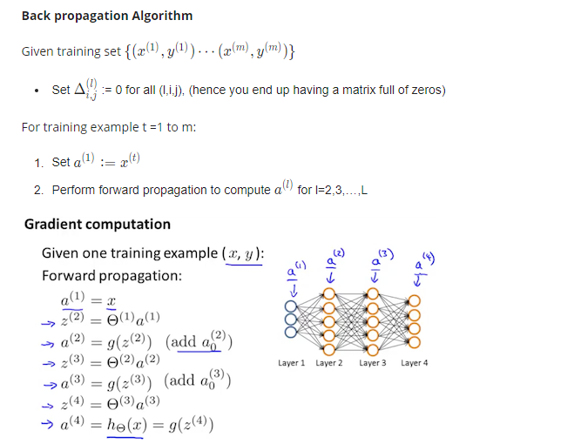

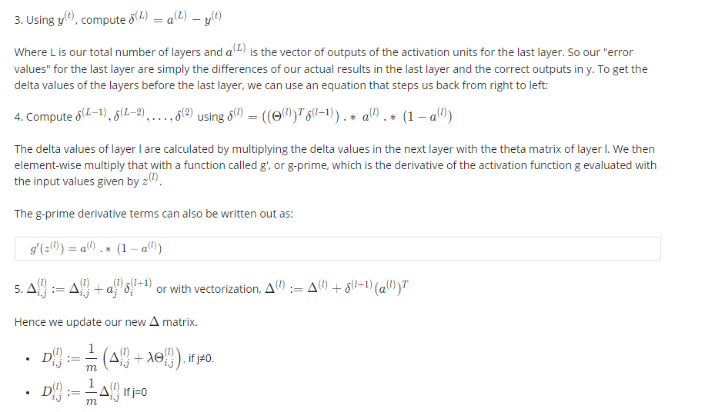



**Bias Neuron:**

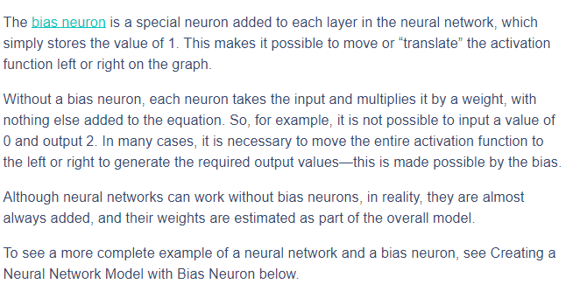

**Where are the bias neurons?**As explained above, biases in neural networks are extra neurons added to each layer, which store the value of 1. In our example, the [bias neurons](https://missinglink.ai/guides/neural-network-concepts/neural-networks-regression-part-1-overkill-opportunity/) are b1 and b2 at the bottom. They also have weights attached to them (which are learned during backpropagation).

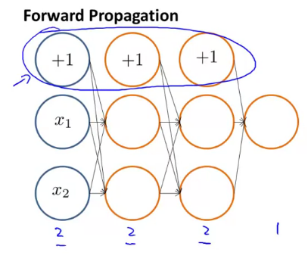

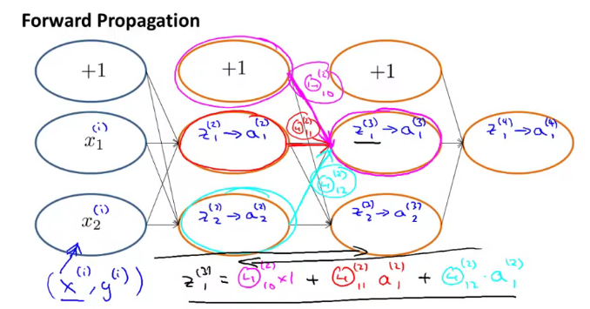

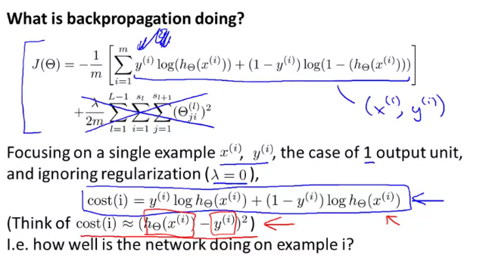

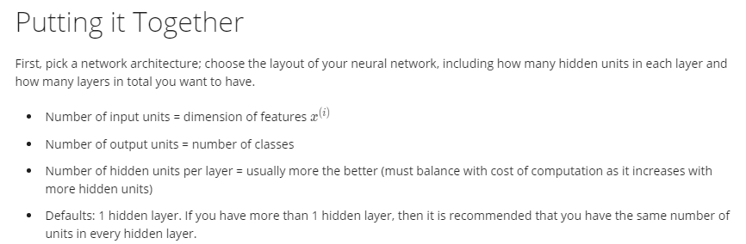

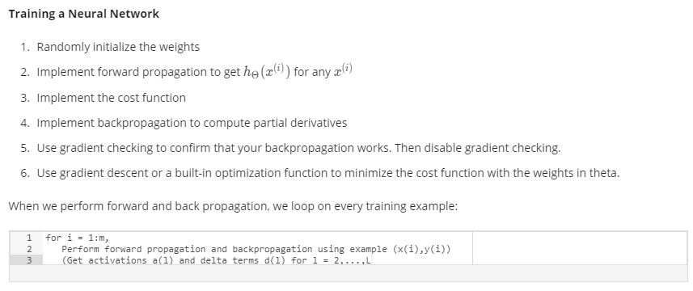

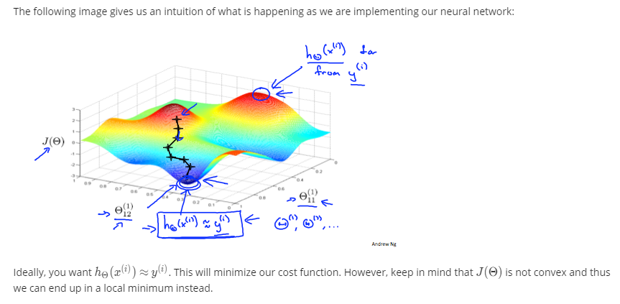

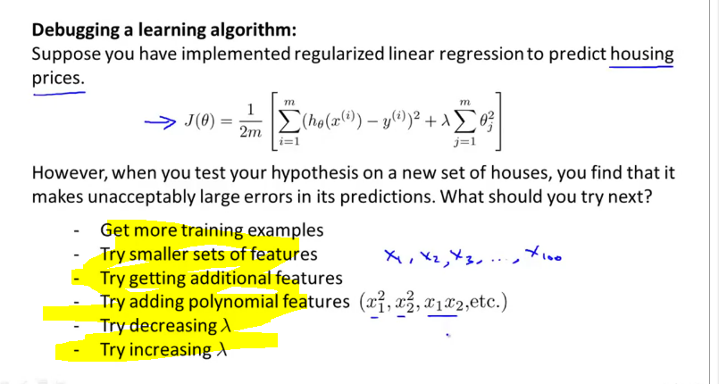

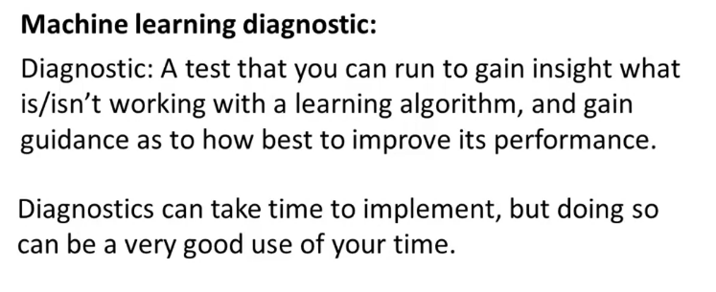

**How to find overfitting?**

1. **Plot it(It’s difficult to plot more features )**
2. **Split train and test Randomly/shuffle**

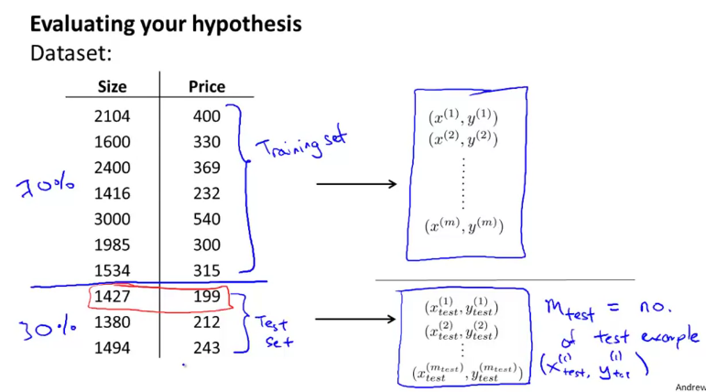

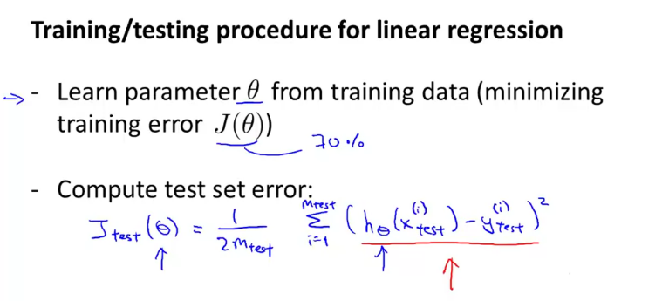

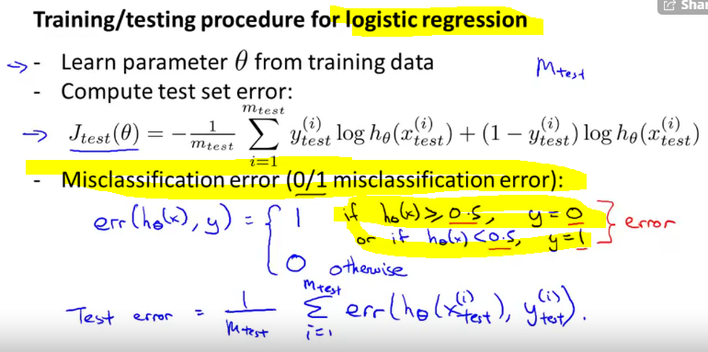

**How to select the model?**

**What degree of polynomial I should pick.**

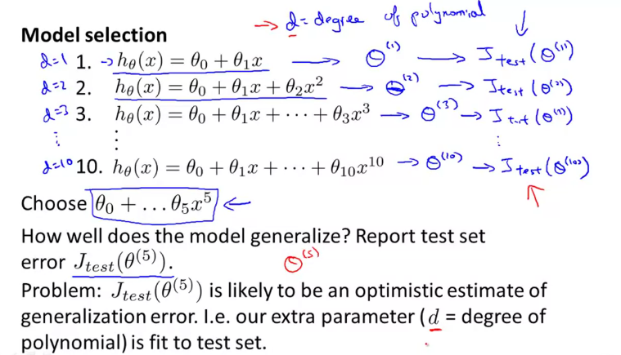

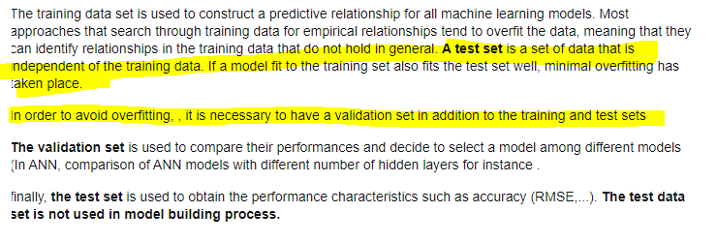

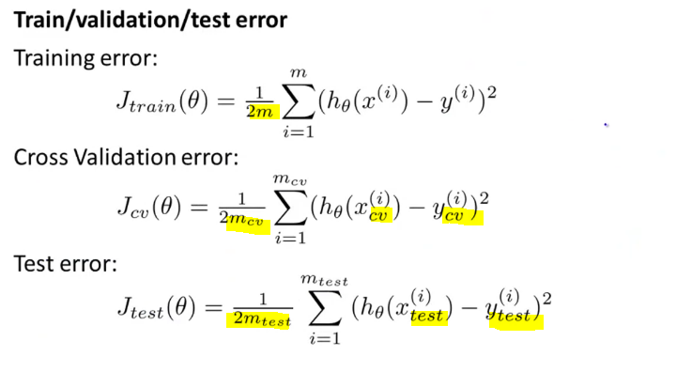

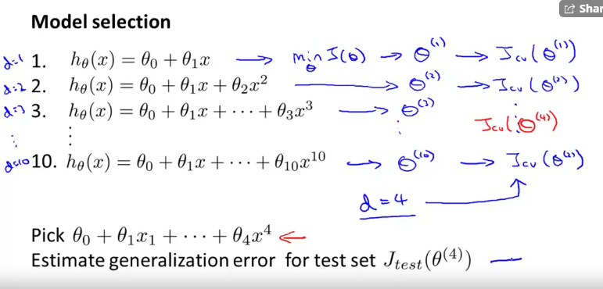

**Model selection based on the cross validation.**

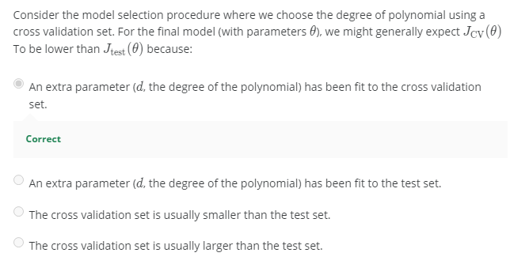

In this approach we randomly split the complete data into training and test sets. Then Perform the model training on the training set and use the test set for validation purpose, ideally split the data into 70:30 or 80:20. With this approach there is a possibility of high bias if we have limited data, because we would miss some information about the data which we have not used for training. If our data is huge and our test sample and train sample has the same distribution then this approach is acceptable.

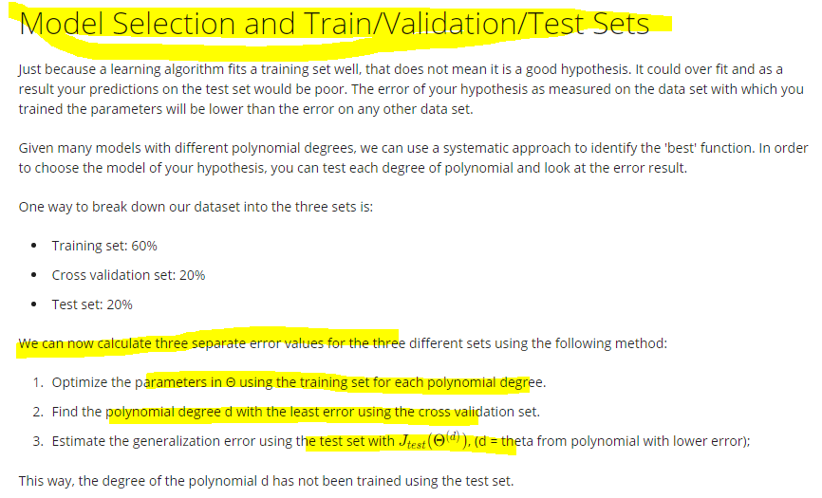

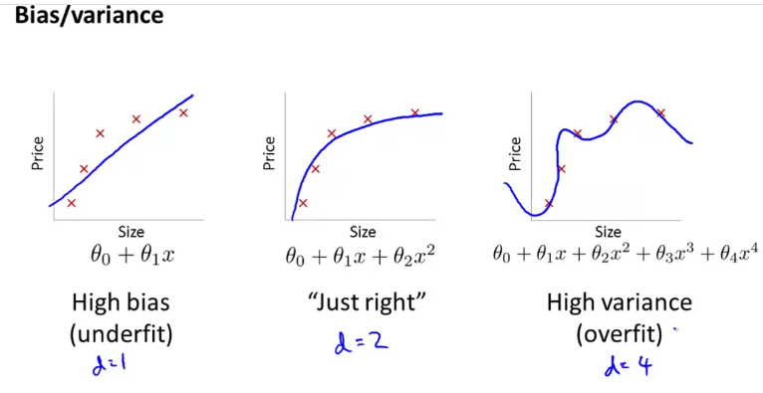

**As d increases, the fitting increases.**

**Error decreases as degree of polynomial increases.**

**Pink🡪 Over fitting**

**Red🡪 Underfitting**

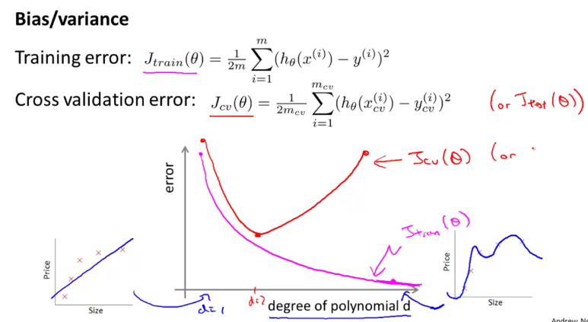

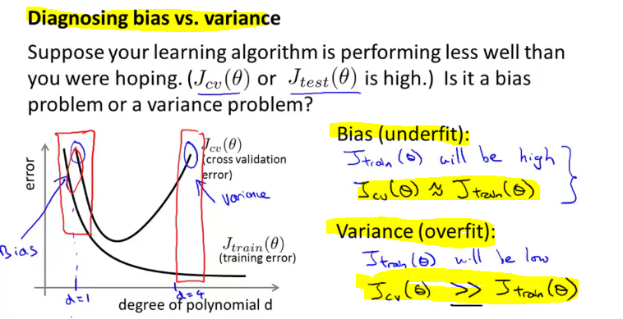

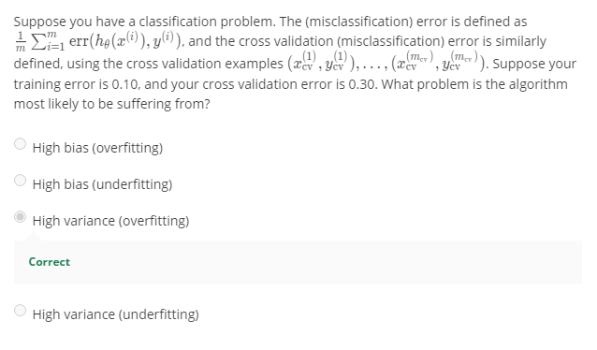

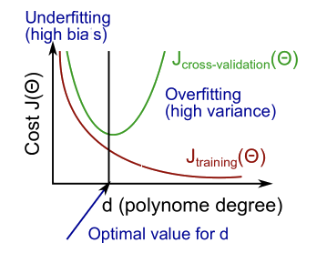

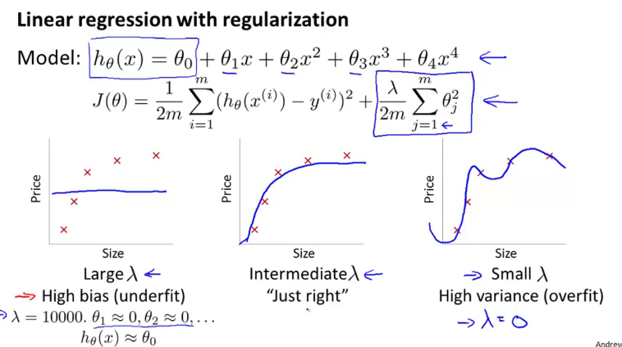

**How to choose Lambda?**

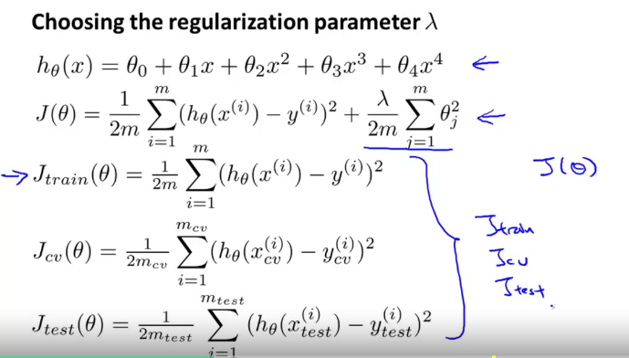

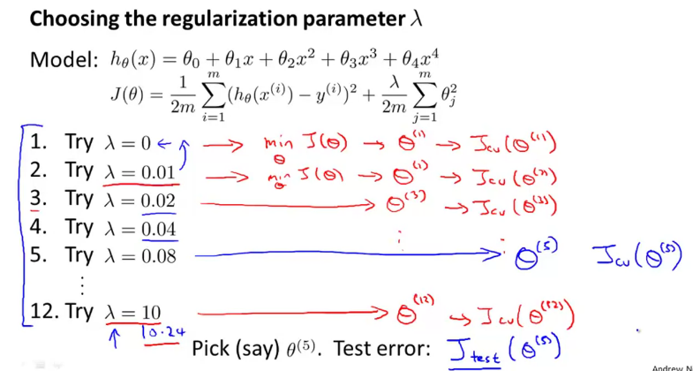

**Same as selecting the model, use Cross validation with less error and finally check with the unseen data.**

**If lambda is small-> Overfitting**

**If lambda is big🡪 Underfitting**

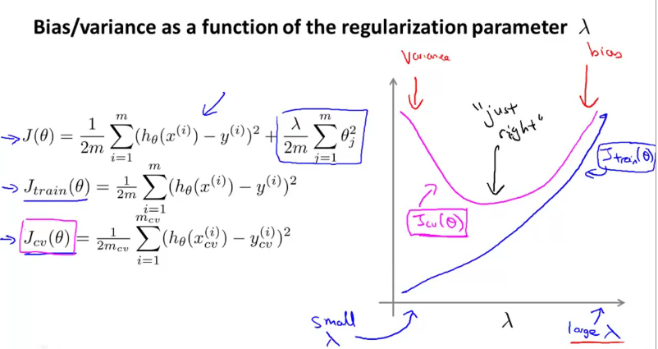

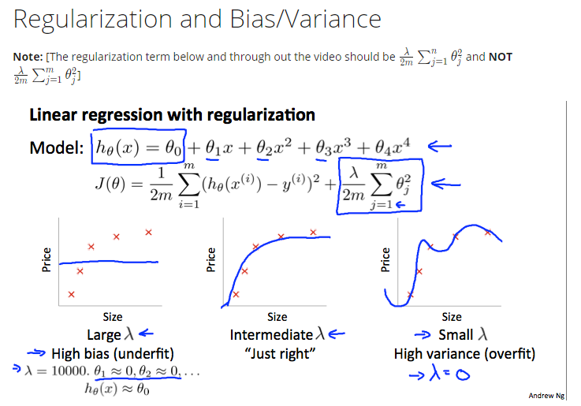

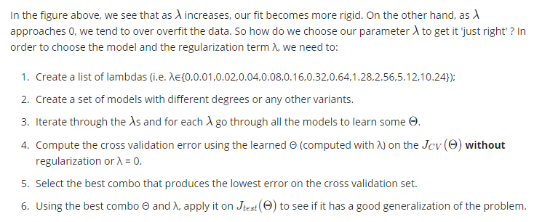

**As the training set increases, the error also increases because the degree of polynomial to fit for all the points would be difficult.**

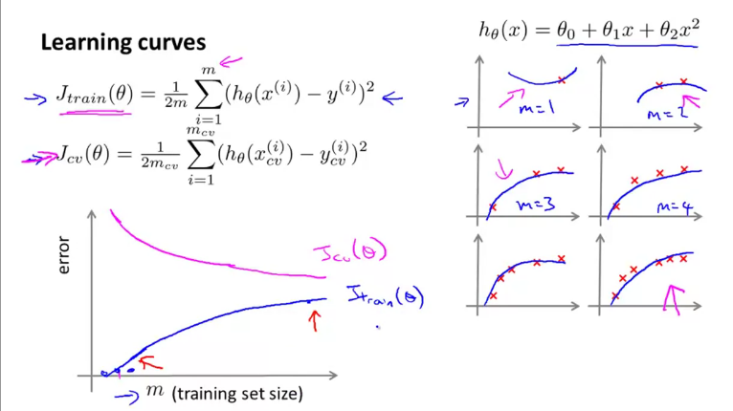

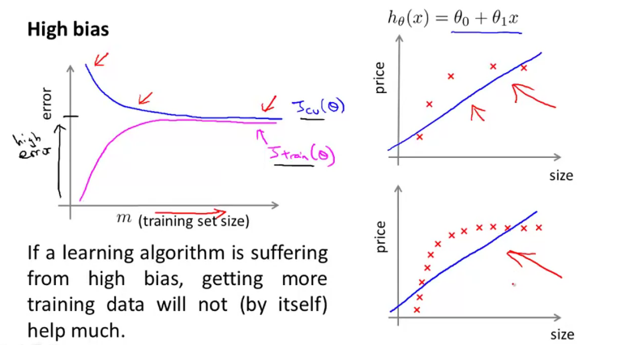

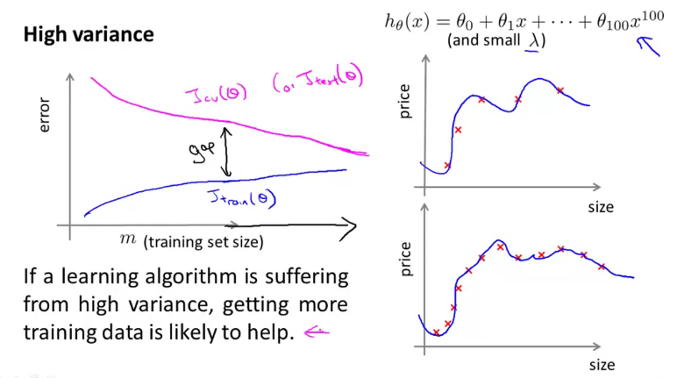

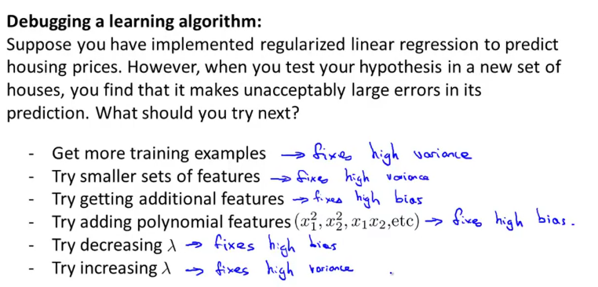

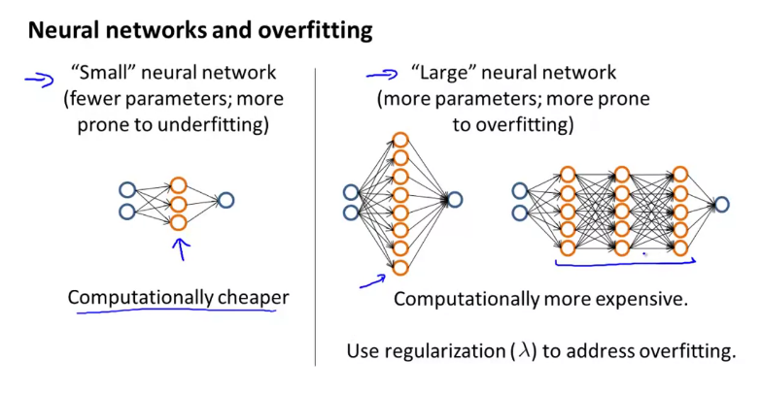

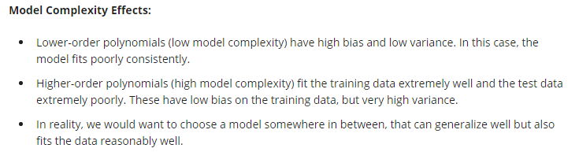



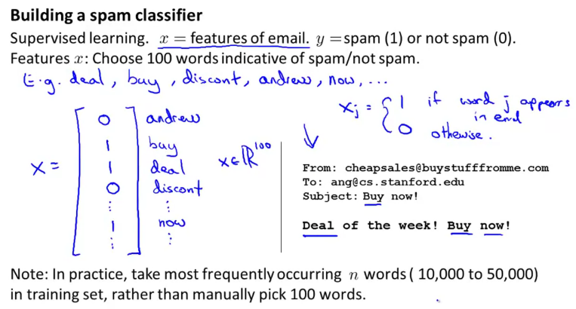

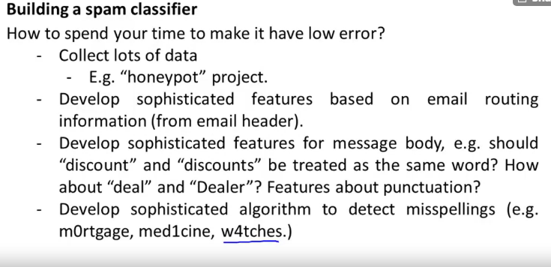

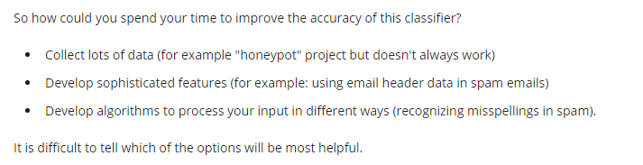

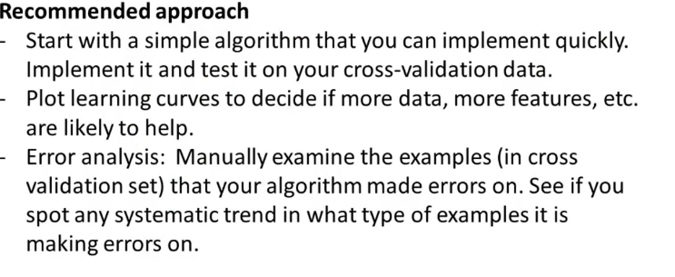

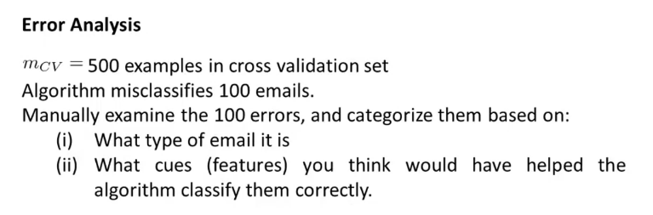

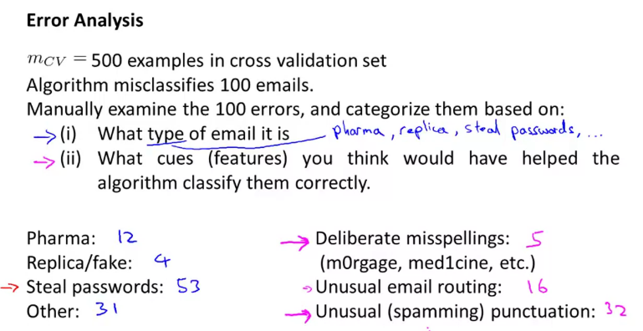

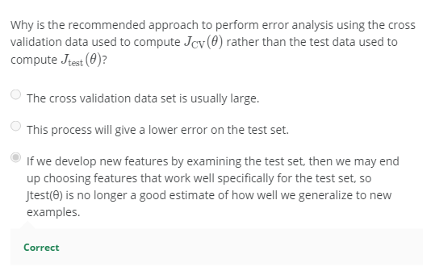

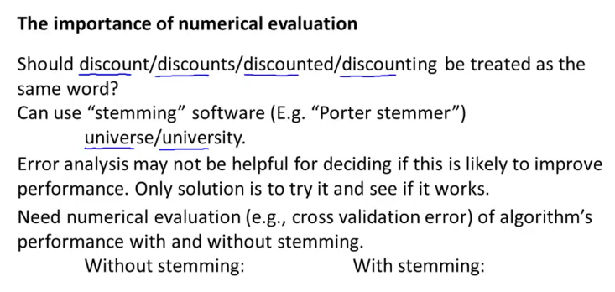

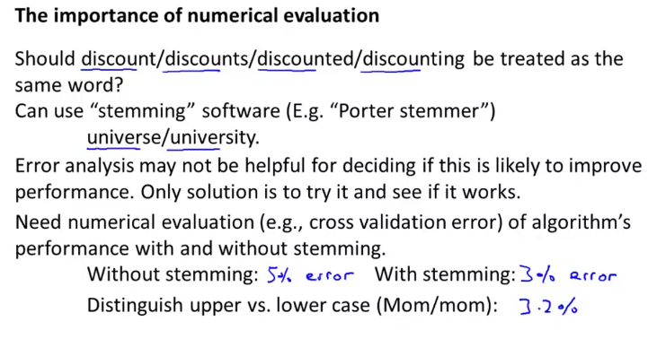

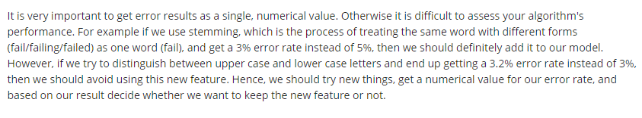

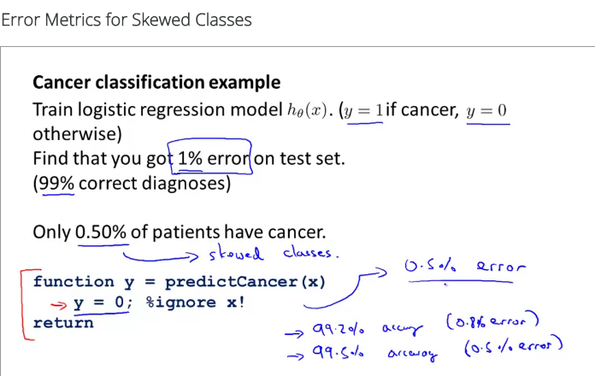

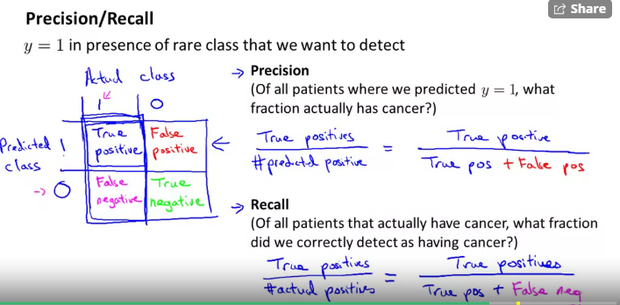

**To handle Skewed Handled Data for error metrics, we use Precision and Recall to analyse the model performance.**

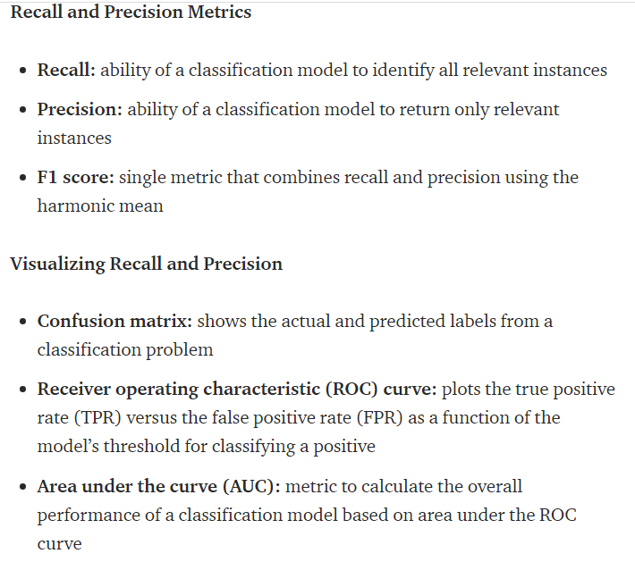

**Higher Recall🡪 if we approach more people by setting the threshold as 0.3 (Type 2 error is handled)**

**Higher Precession🡪 Accurately find the person who has cancer, but we might miss many (Type 1 error is handled)**

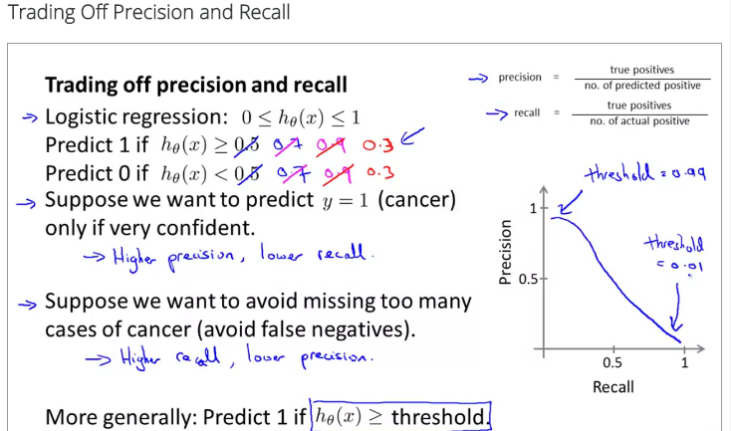

**If we have 2 real numbers to compare the algorithm, it will be complex . Hence we use F1 score.**

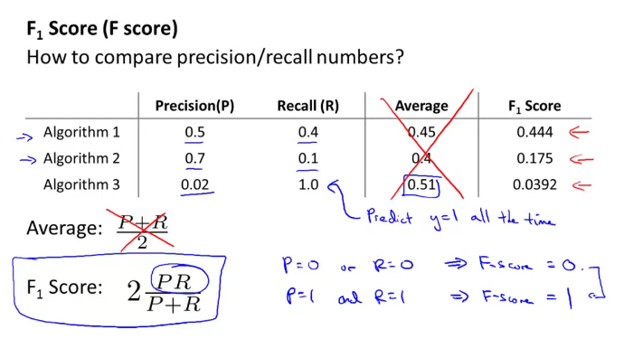

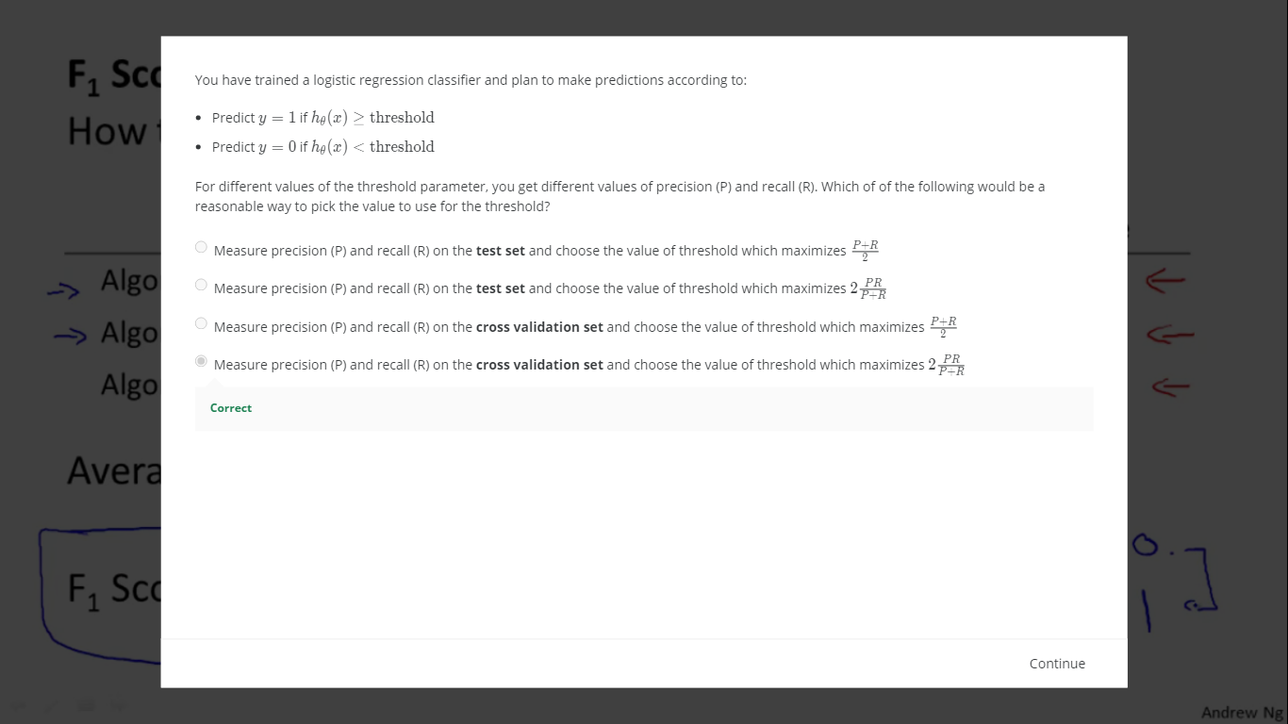

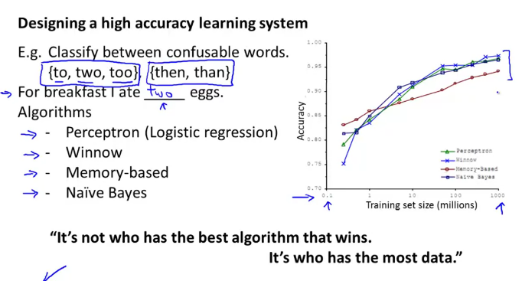

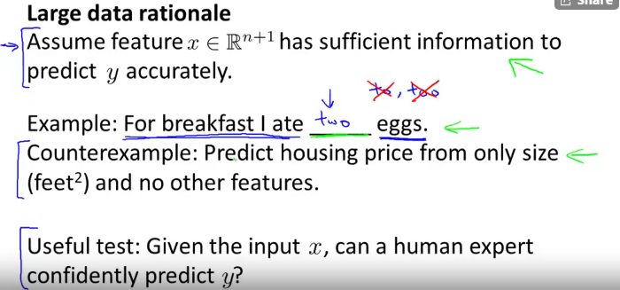

**It’s insufficient to predict the house price only with the size of the house**

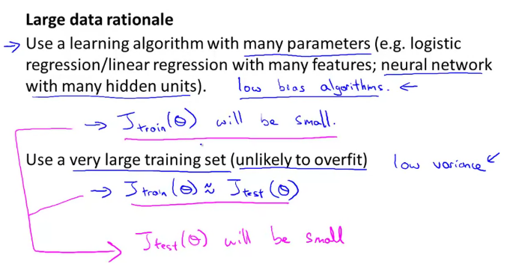

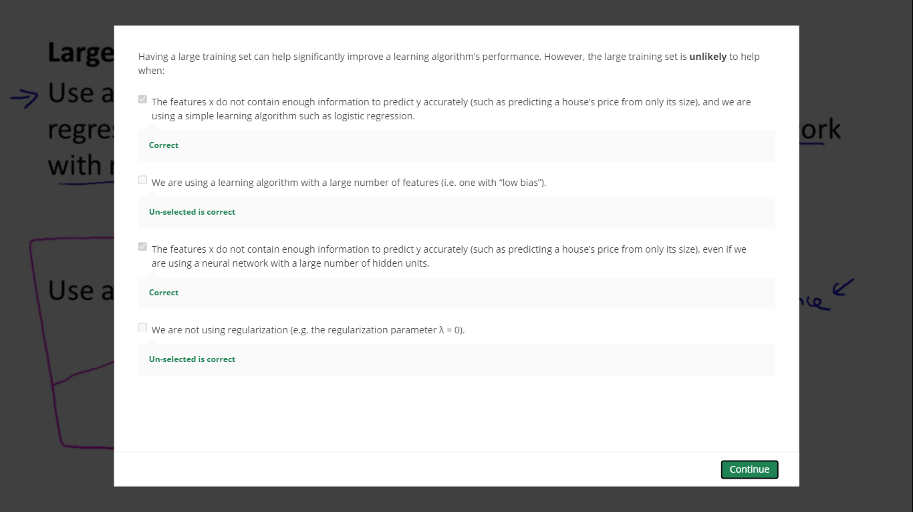

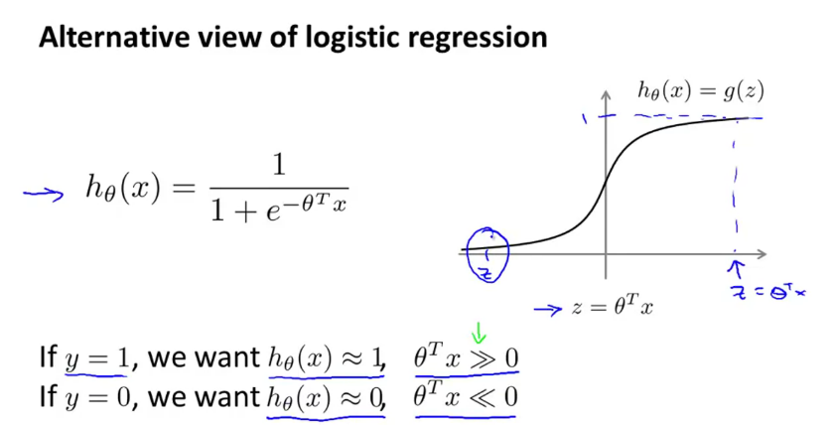

**SUPPORT VECTOR MACHINE (SVM):**

**Modifying logistic regression to give SVM.**

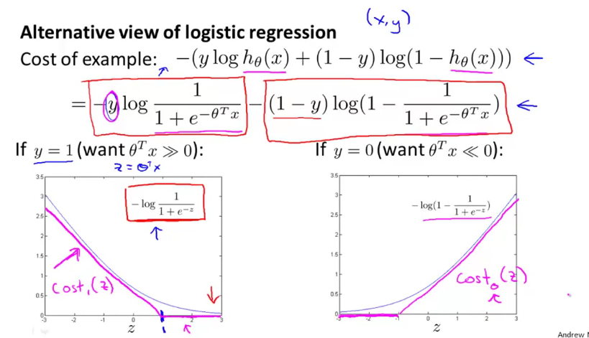

**m is not needed, see the red explanation.**

**A+ lambda*B 🡪 Logistic Regression**

**CA+B 🡪 SVM**

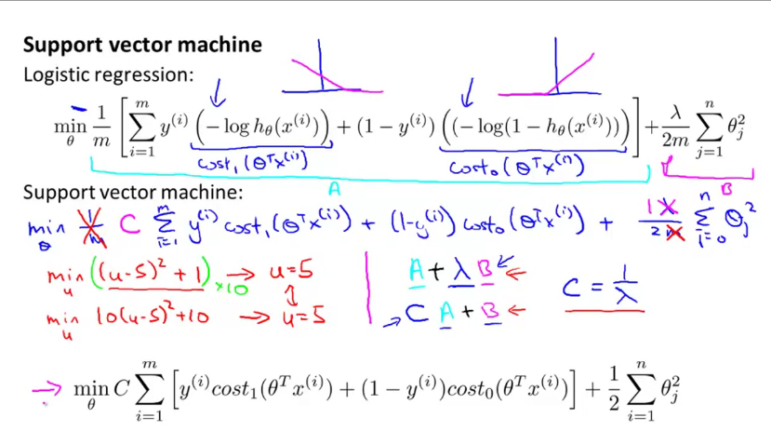

**Replacing Lambda with C.**

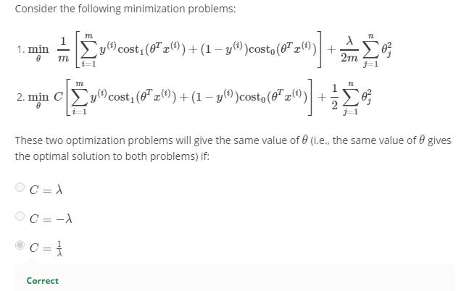

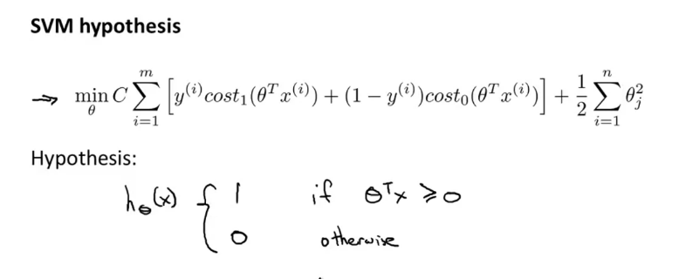

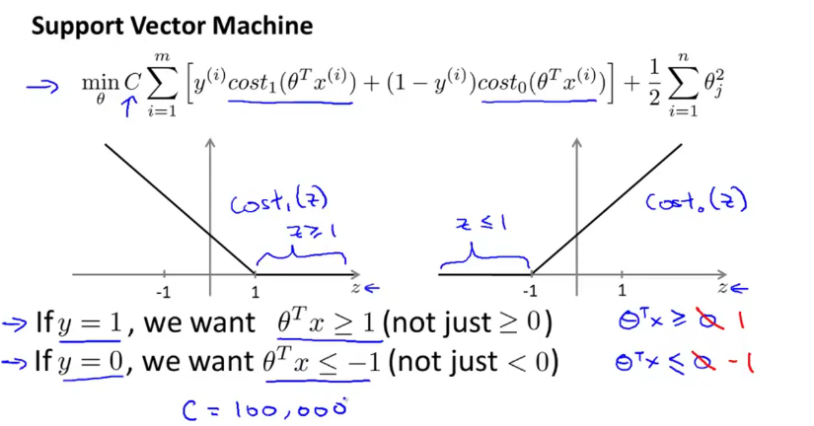

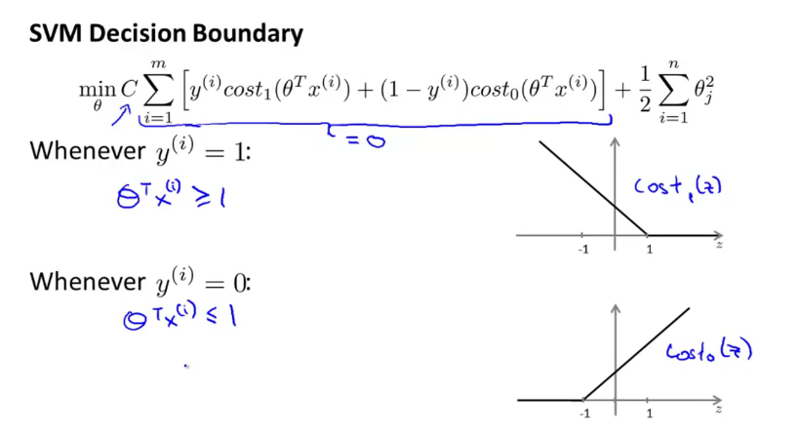

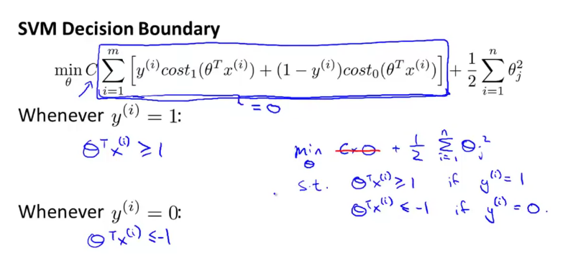

**Black line is SVM,**

**SVM called as Large Margin Classifier**

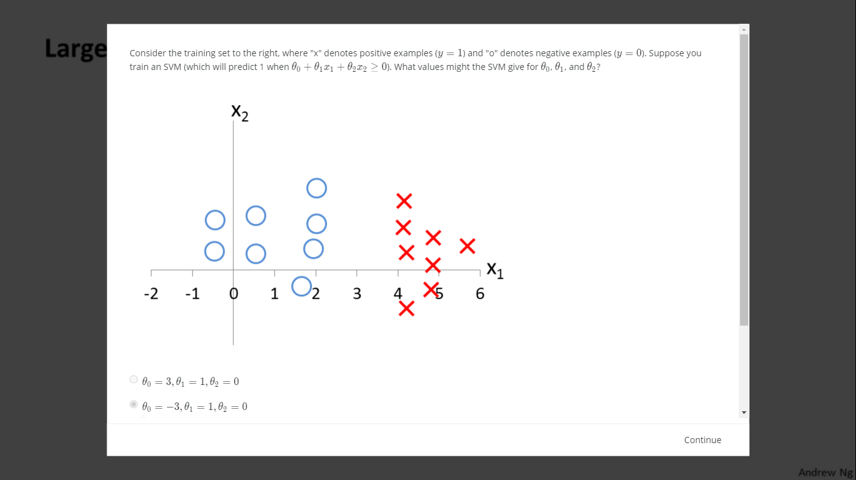

**SVM is sensitive to outliers when C is very large**

**When C is not too larger, it can leave few outliers.**

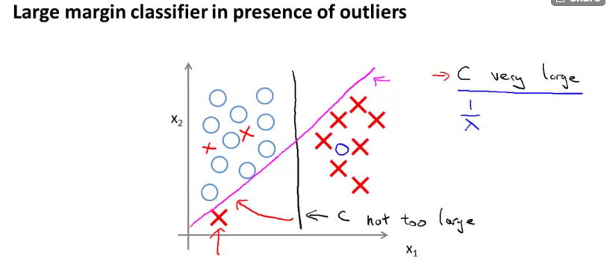

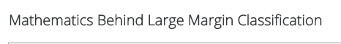

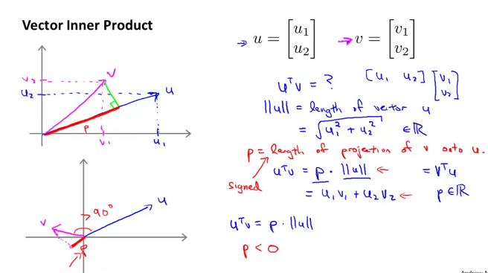

**UNSUPERVISED LEARNING**

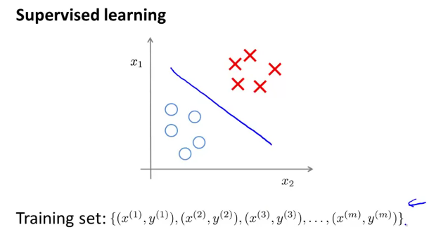

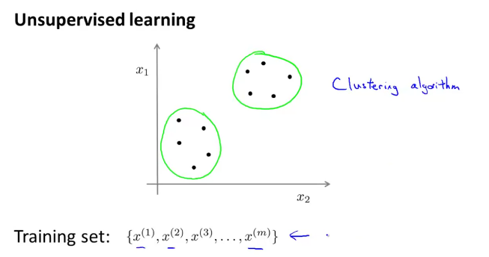

**There is no y in unsupervised learning.**

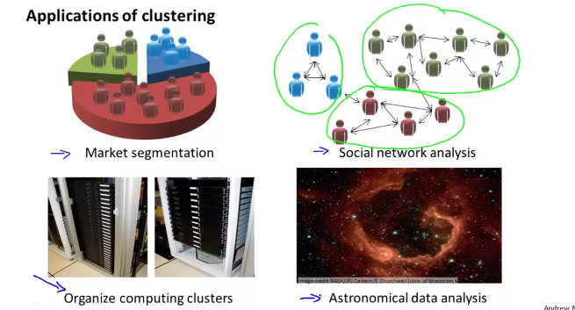

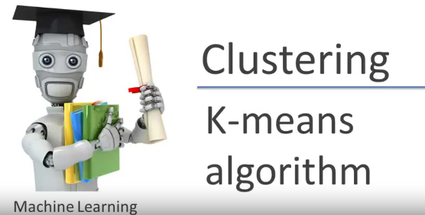

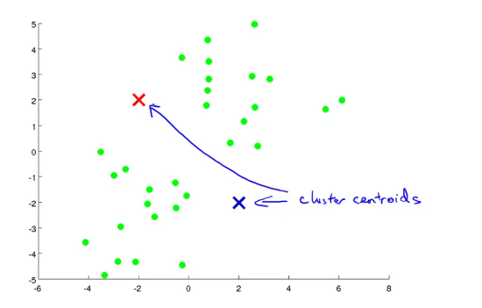

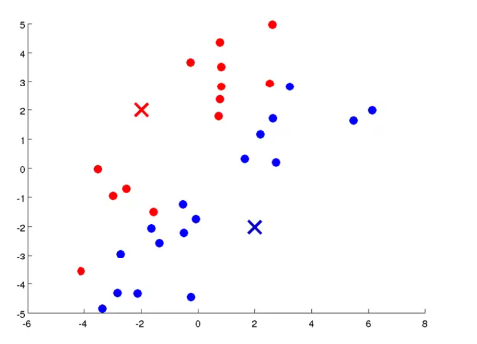

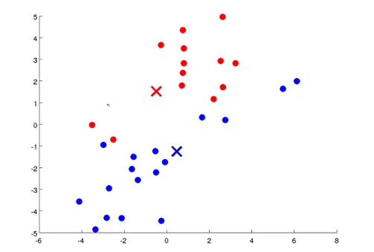

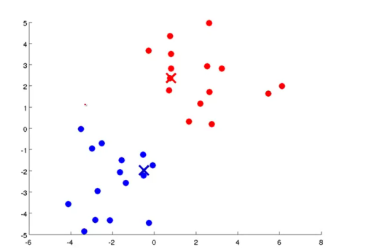

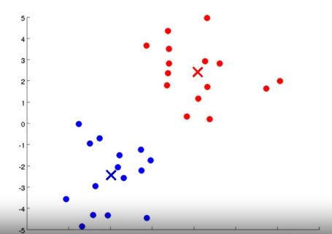

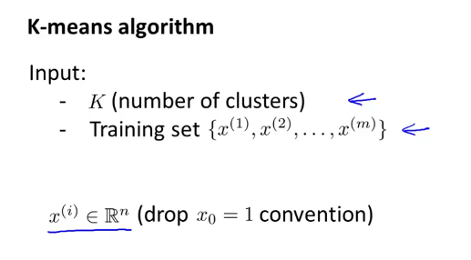

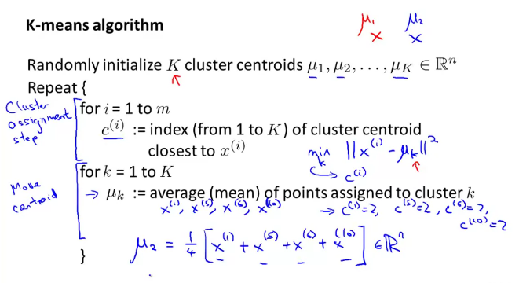

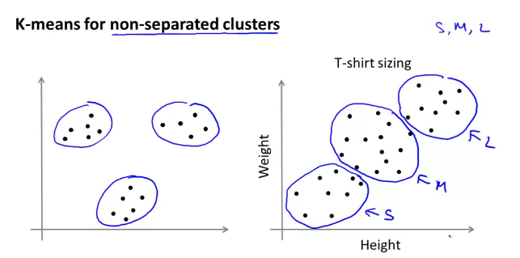

**Training Example- x(i)**

**Location of the cluster centroid-Mu c(i)**

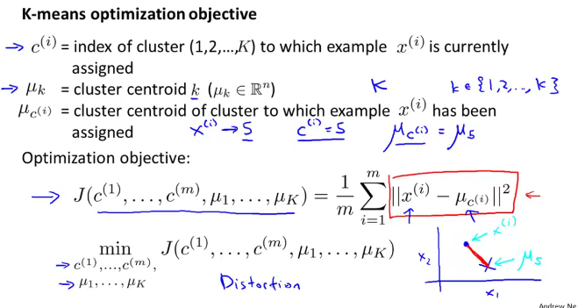

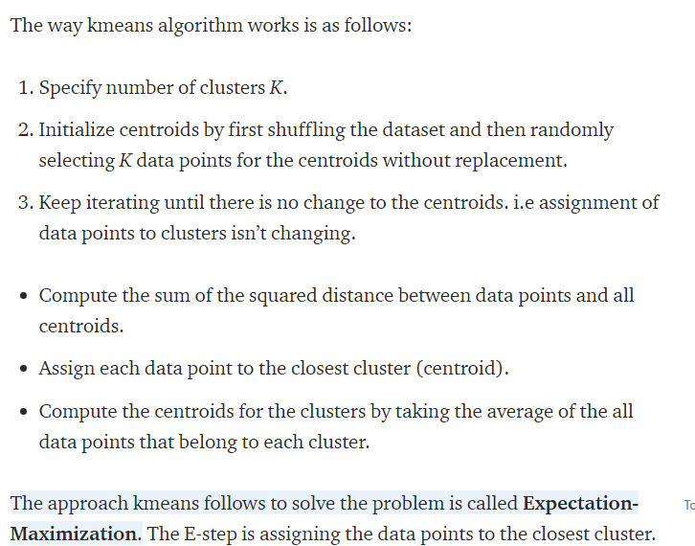

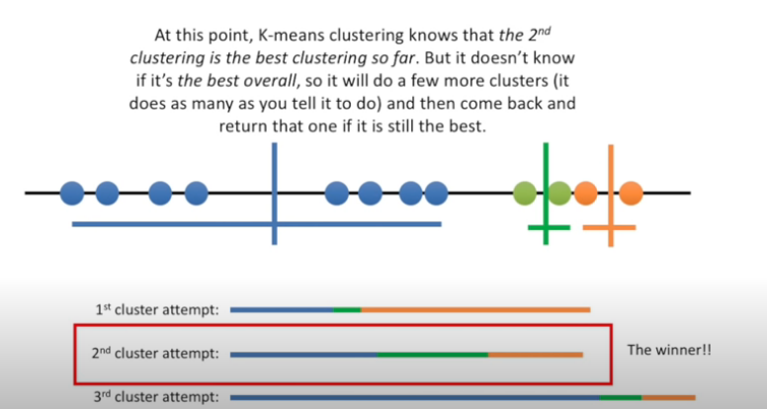

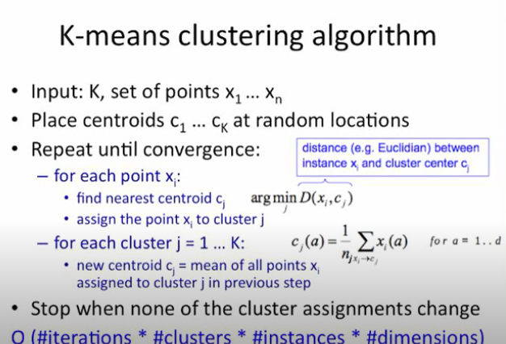

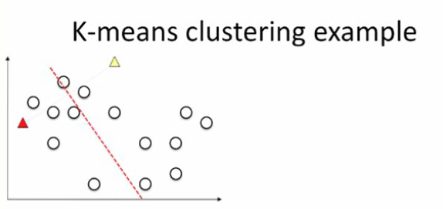

**Dotted line is Euclidean’s distance**

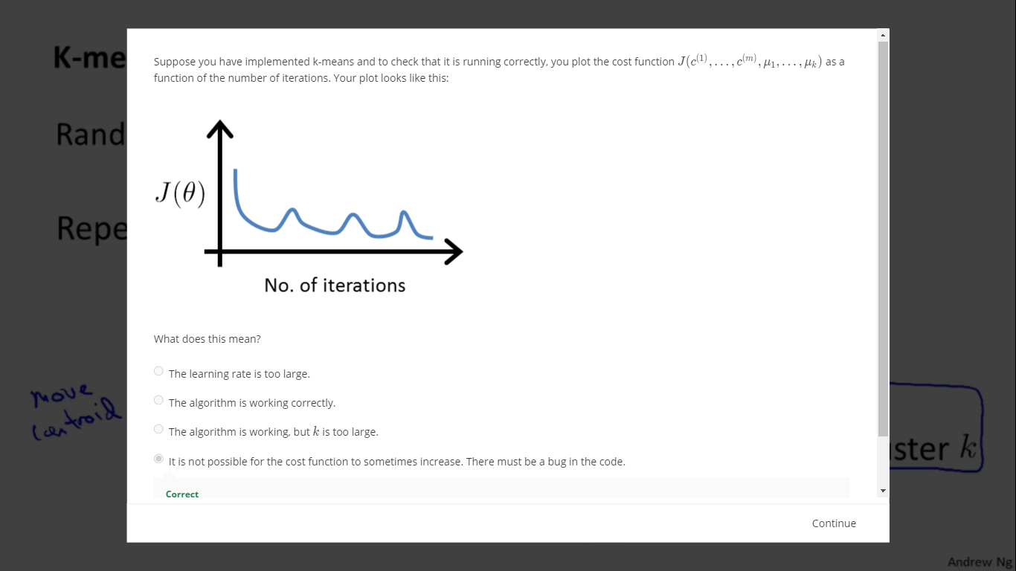

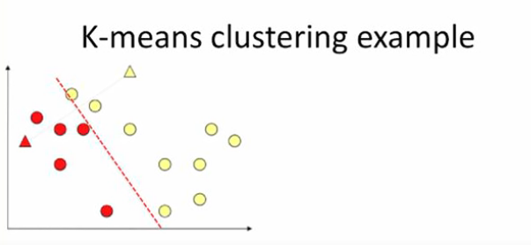

**Take the average (centre of gravity) of red and yellow to calculate the new pos for the centroid.**

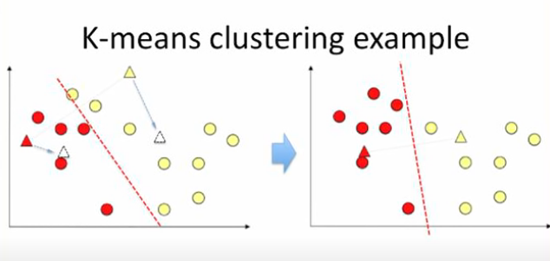

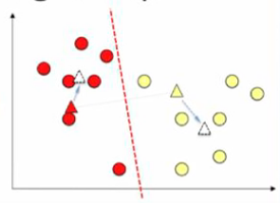

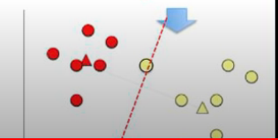

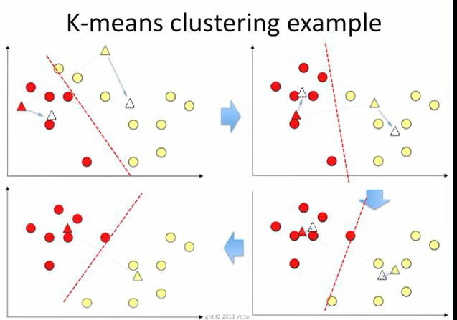

**At some point the average won’t change.**

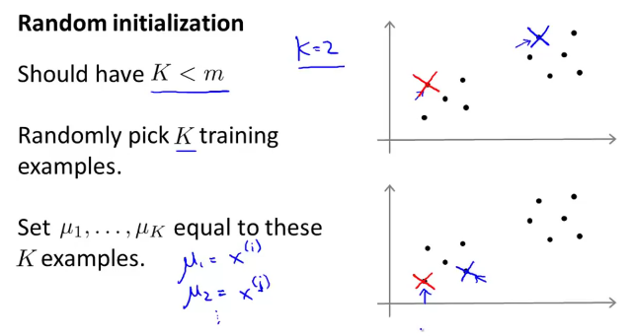

**If the random initialization is unlucky, we might struck at the local optimal.**

**Picture 2 and 3.**

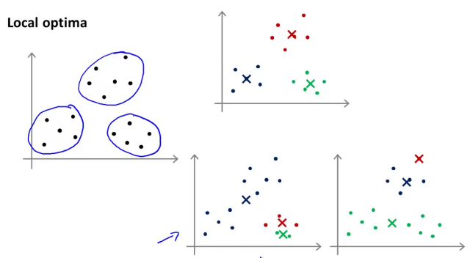

**Try with multiple random initialization and check to get the best solution.**

**Pick the lowest cost.**

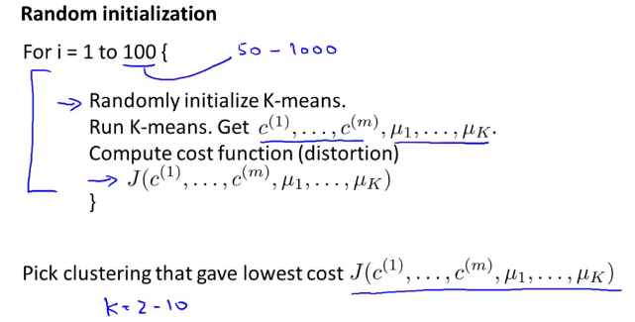

**CHOOSING THE NUMBER OF CLUSTERS:**

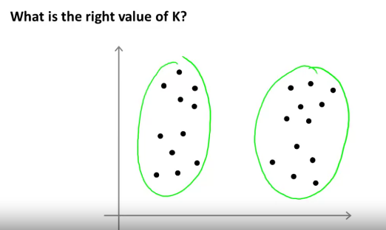

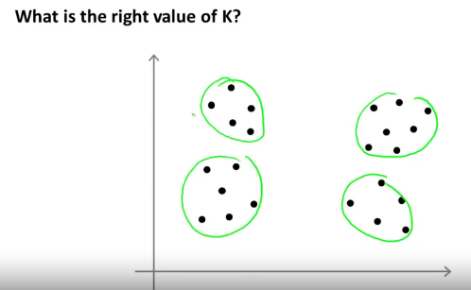

**USE the ELBOW METHOD:**

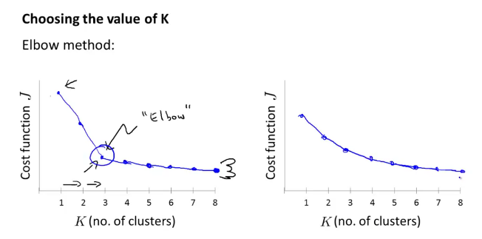

**Sometimes, there won’t be clear convergence in the cost function, like wise in the second image during the elbow method.**

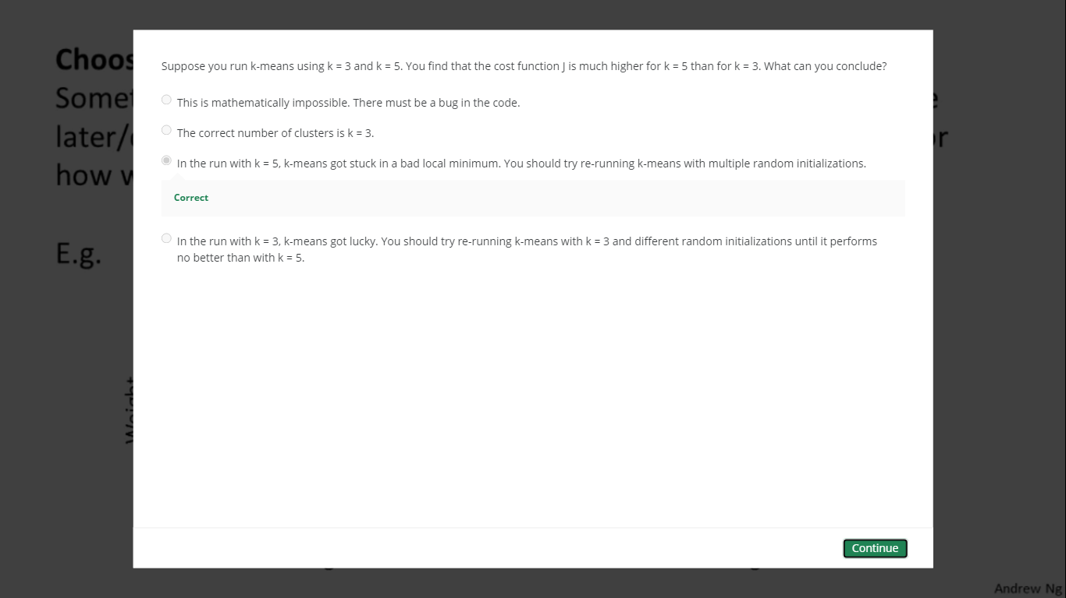

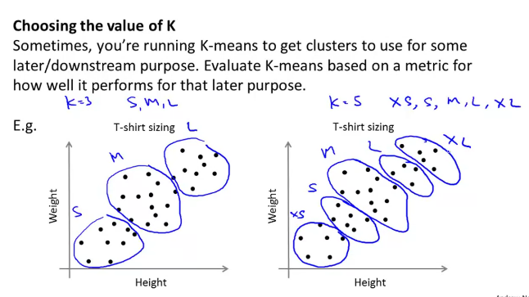

**Choose the k value, based on the business domain. Like above.**

**UNSUPERVISED LEARNING-DIMENSIONALITY REDUCTION:**

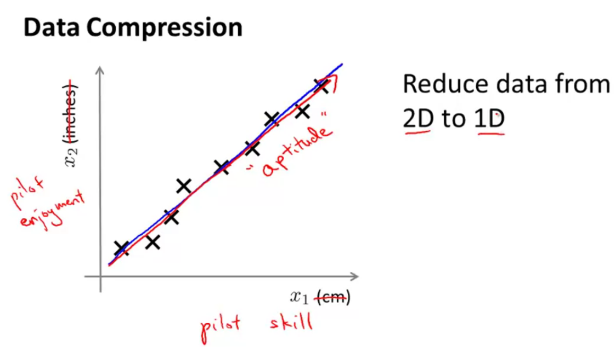

**Use projection, to reduce the dimension**

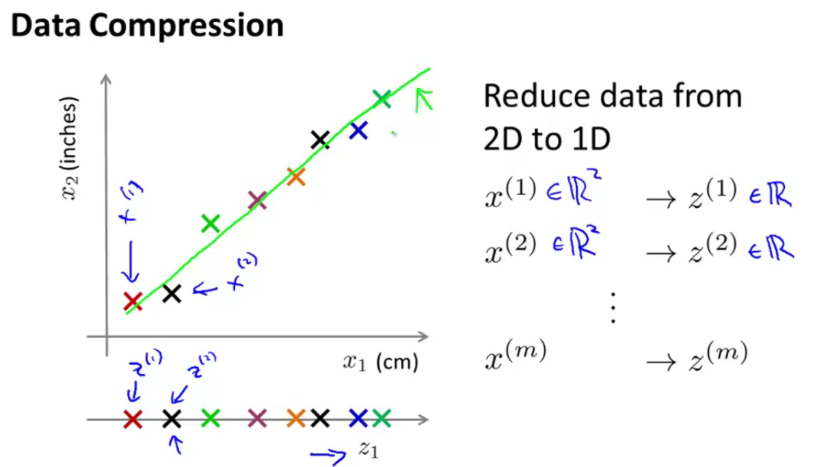

**Data Compression, improves the runtime/performance of the algorithm.**

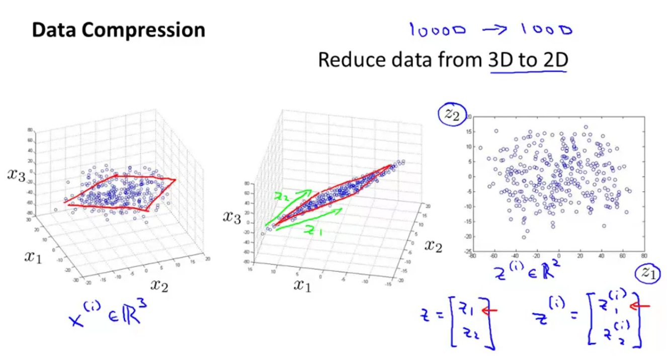

**In 3d, projection is done to the plane**

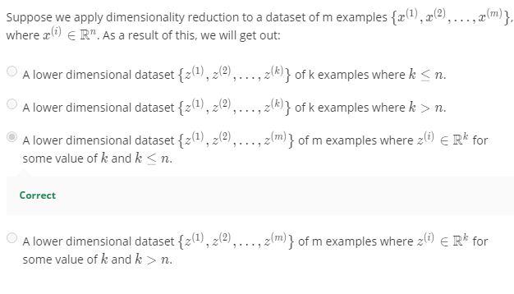

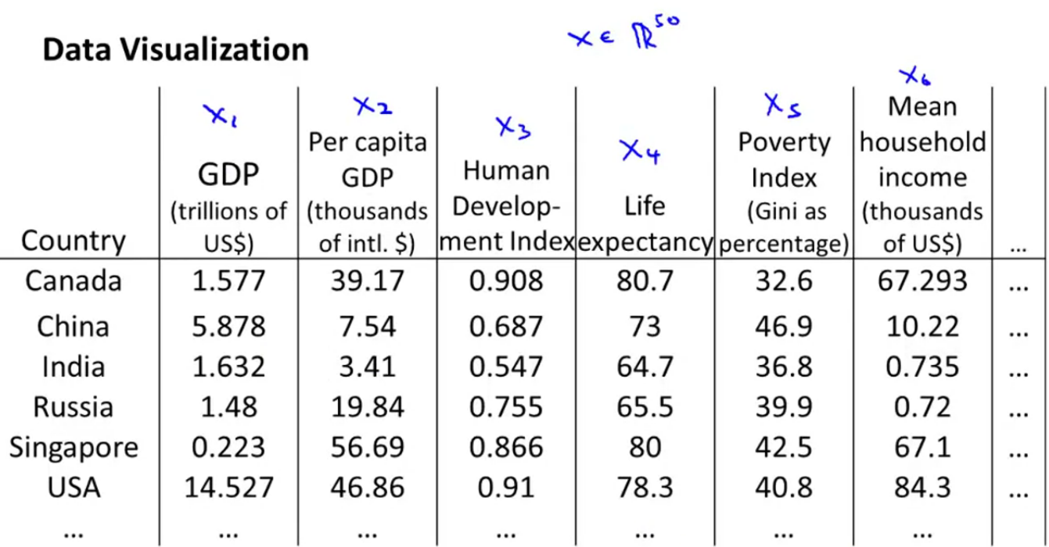

**Summarizing 50 features to 2,**

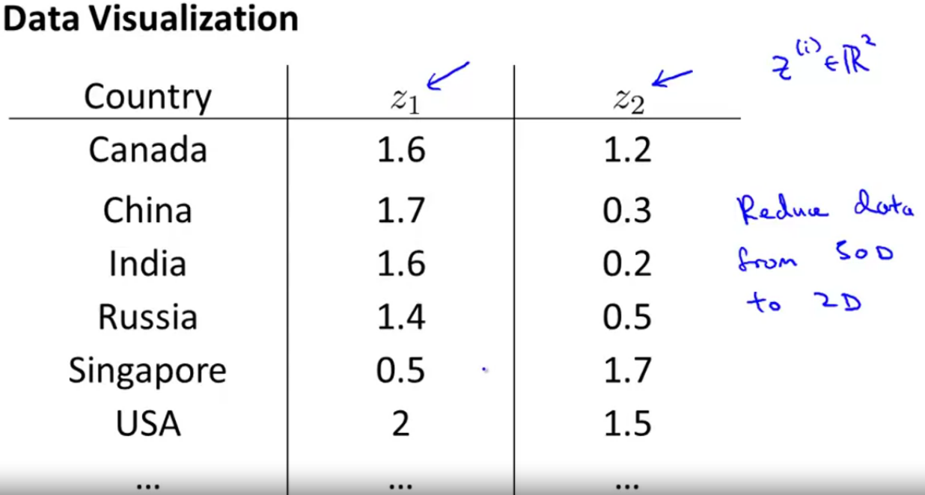

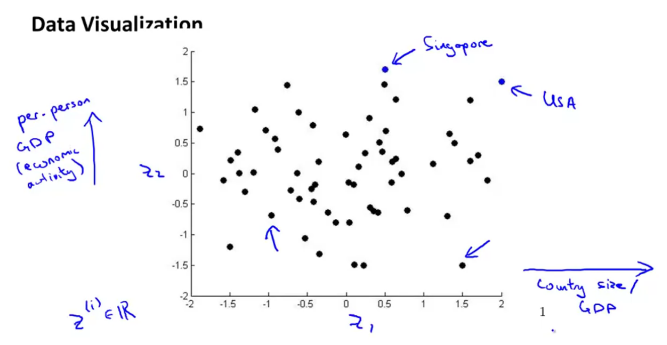

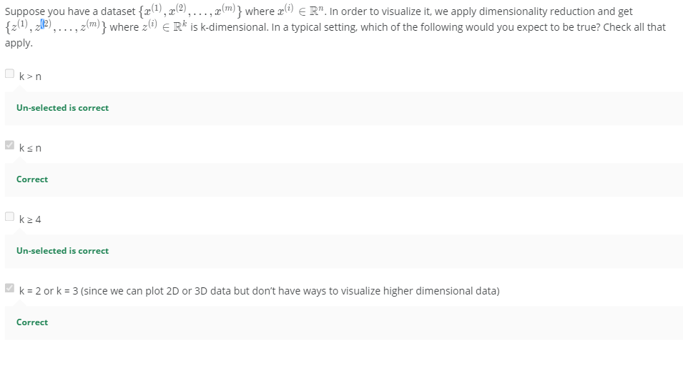

**Principal Component Analysis:**

**Red line is PCA, by projection and error the dimensionality is reduced.**

**Objective is to minimize the projection error.**

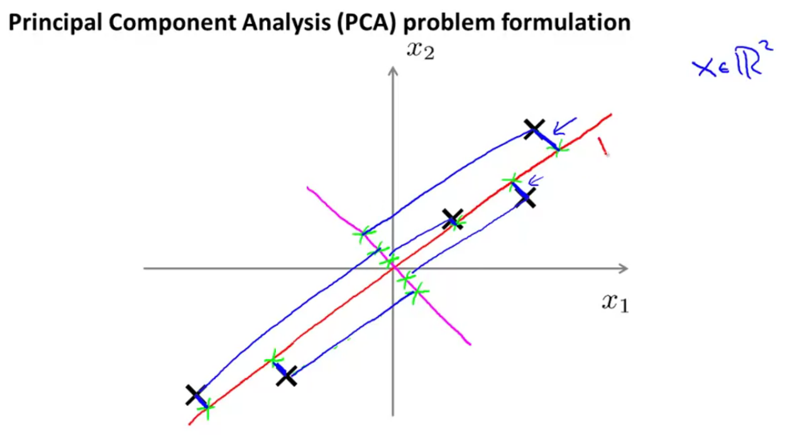

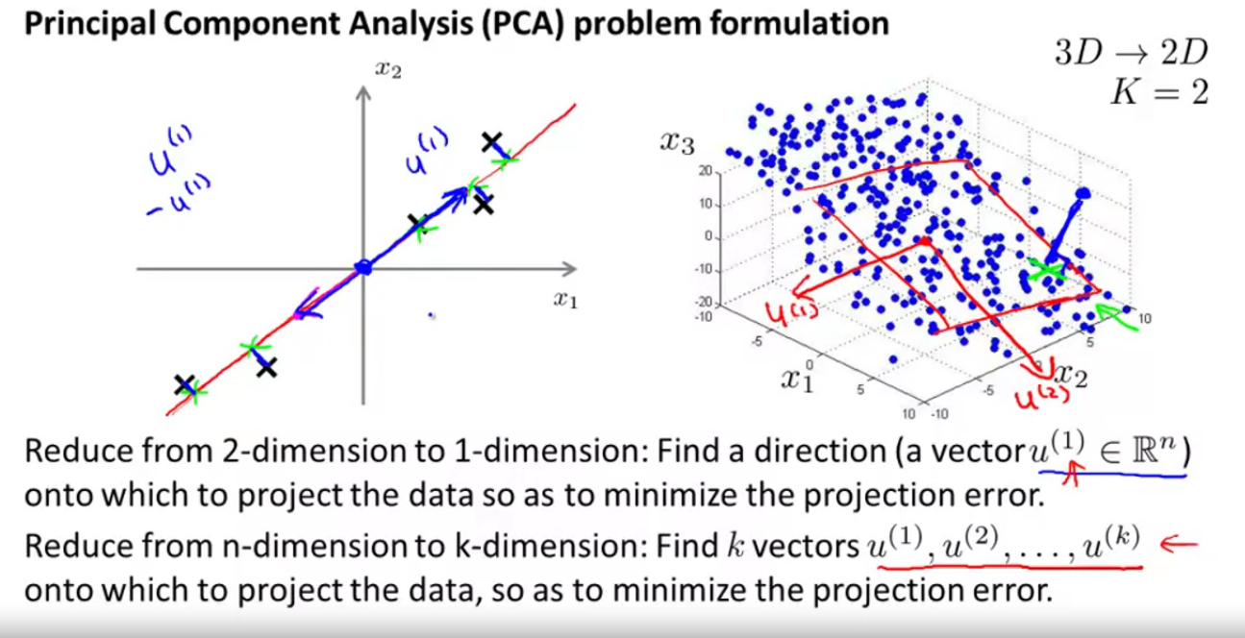

**PCA is not linear regression.**

**The line drawn from the x-point to the line is different.**

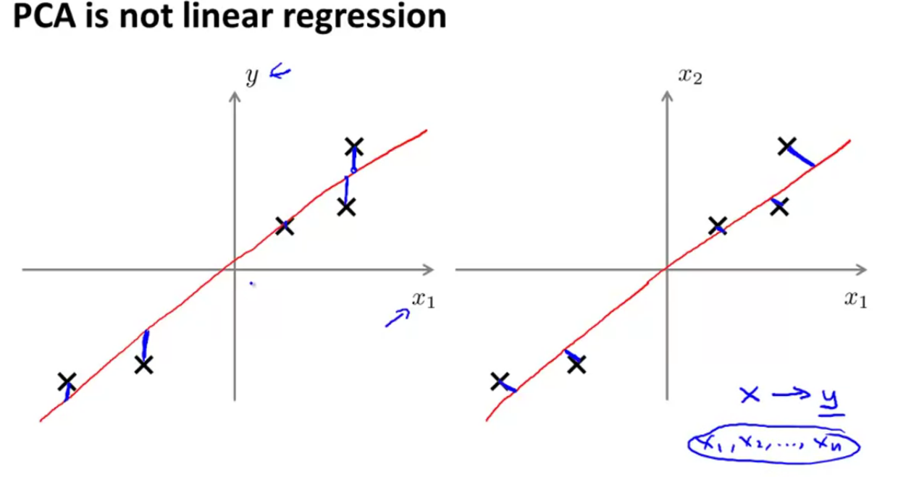

**PCA-Data Preprocessing:**

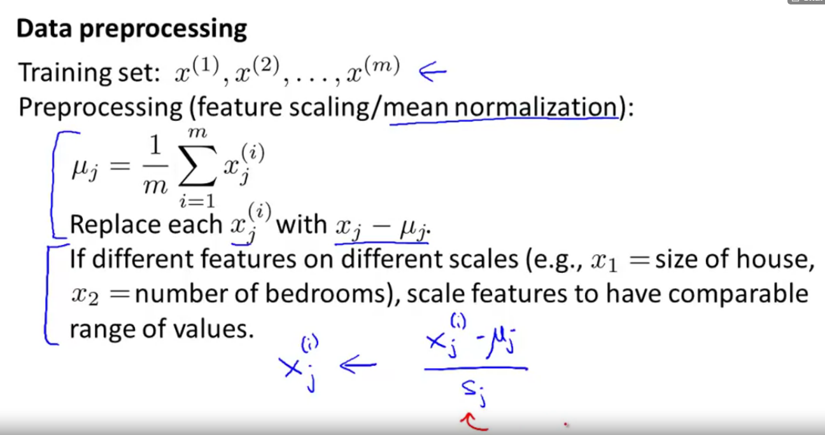

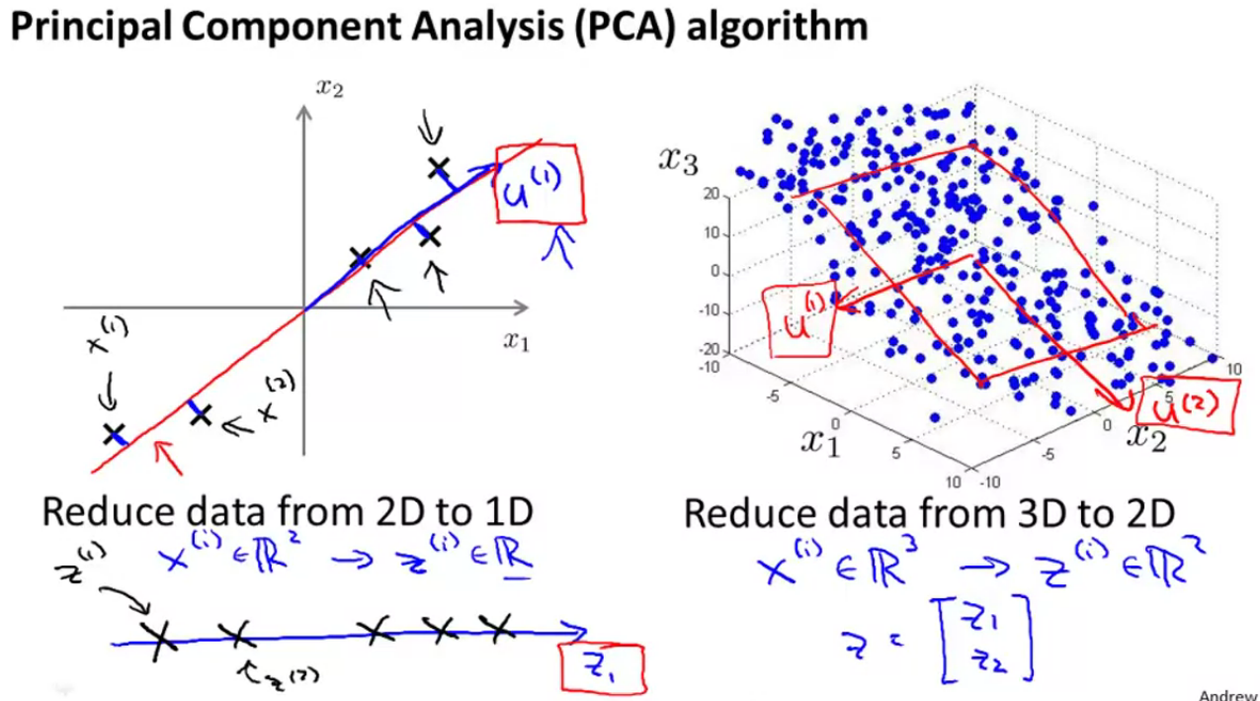

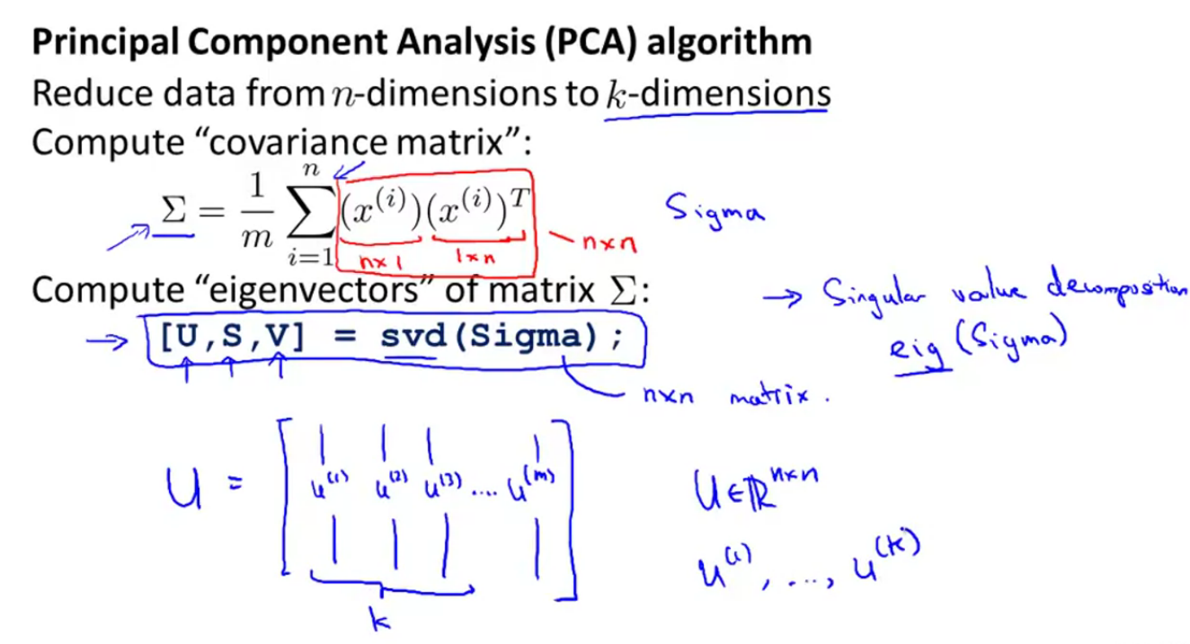

**X🡪 input data(table)**

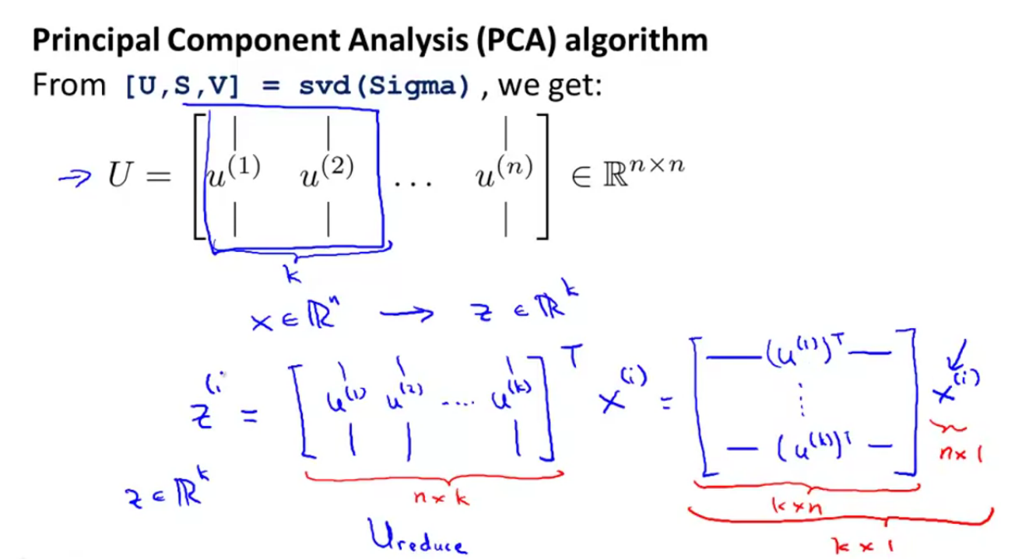

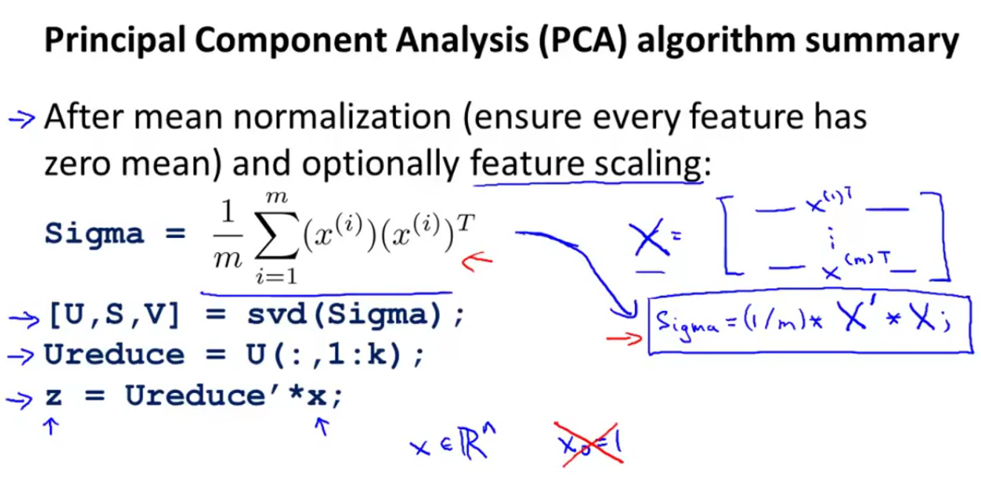

**Reconstruction of compressed representation:**

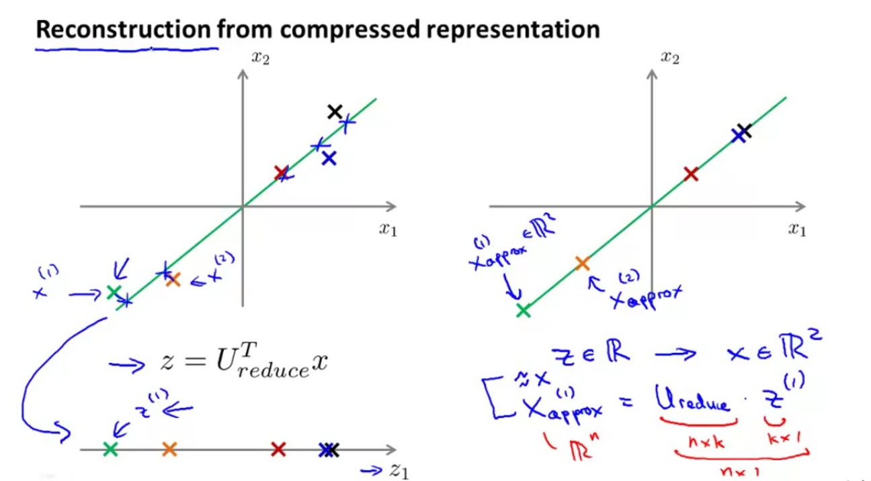

**While choosing k, the variance should be retained. The terminology we should use.(90 to 99)**

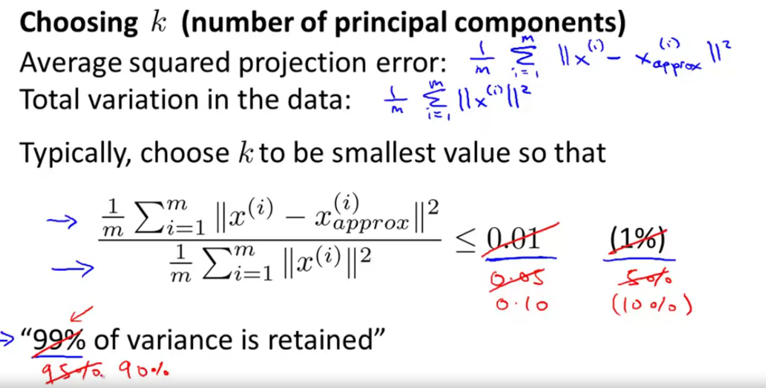

**In real time, most of the data is highly correlated and hence we can compress a lot.**

**Its easier to get the ‘k’ by using SVD (much more efficient).**

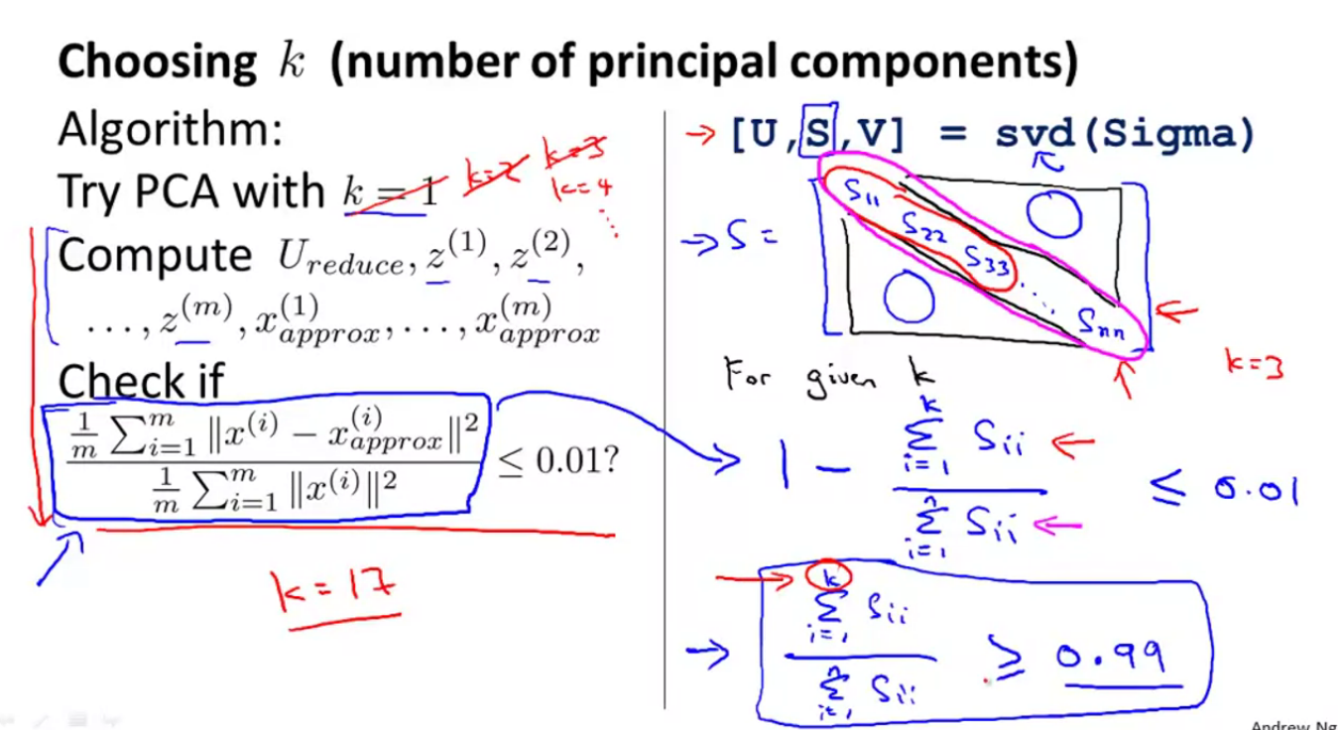

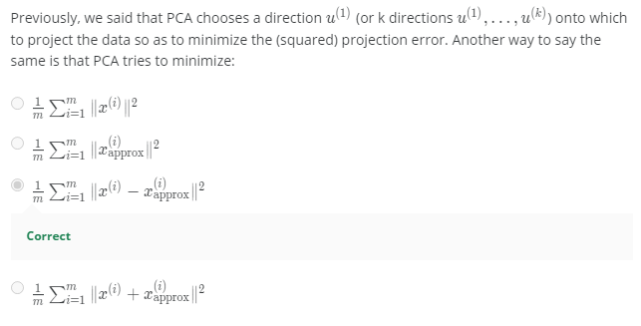

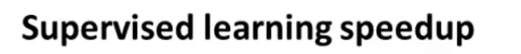

**Reducing the Dimension, increase the run time and performance.**

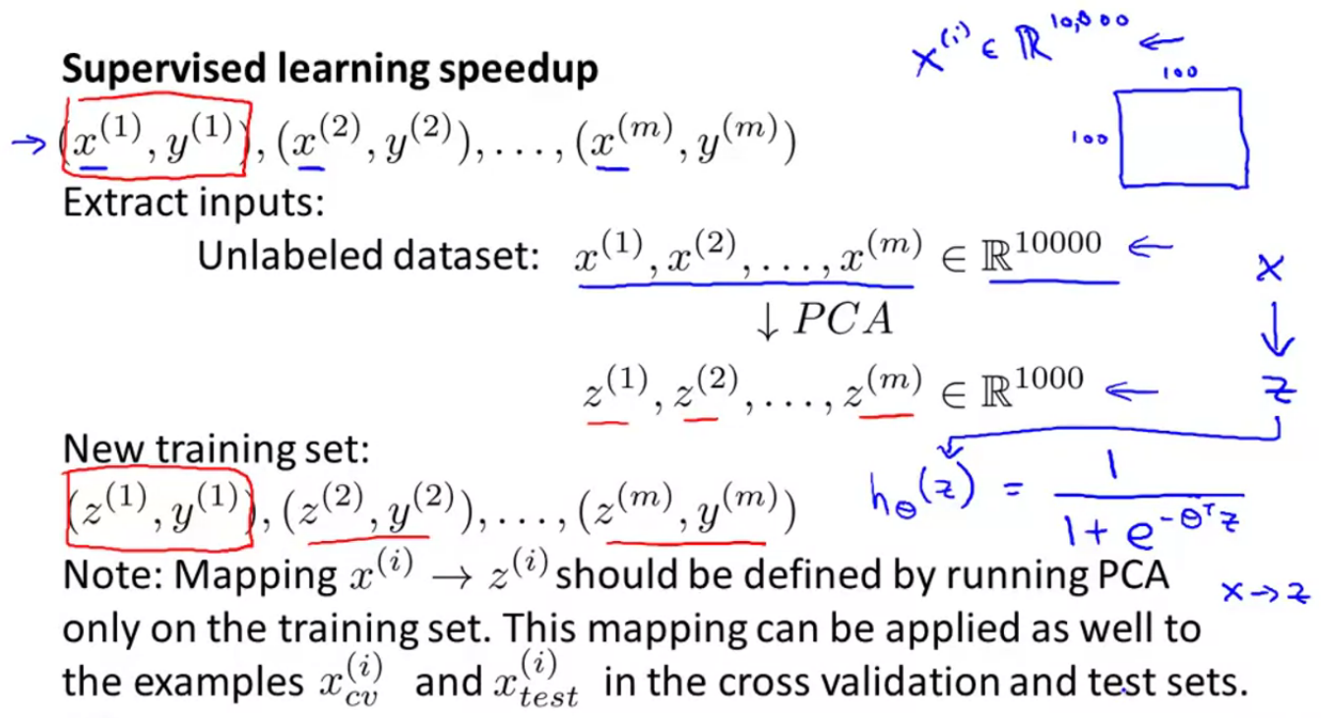

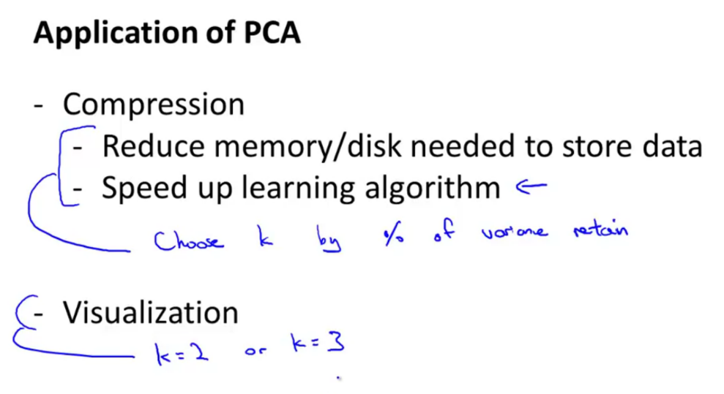

**Bad use:**

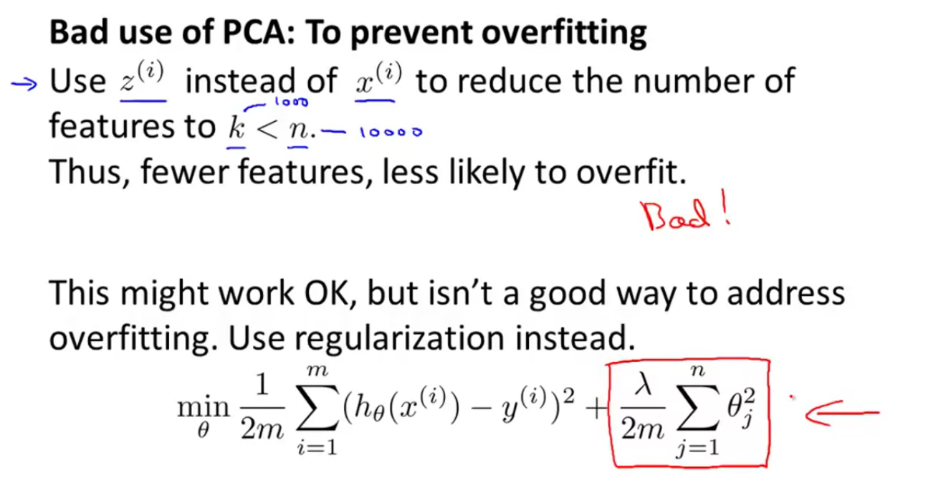

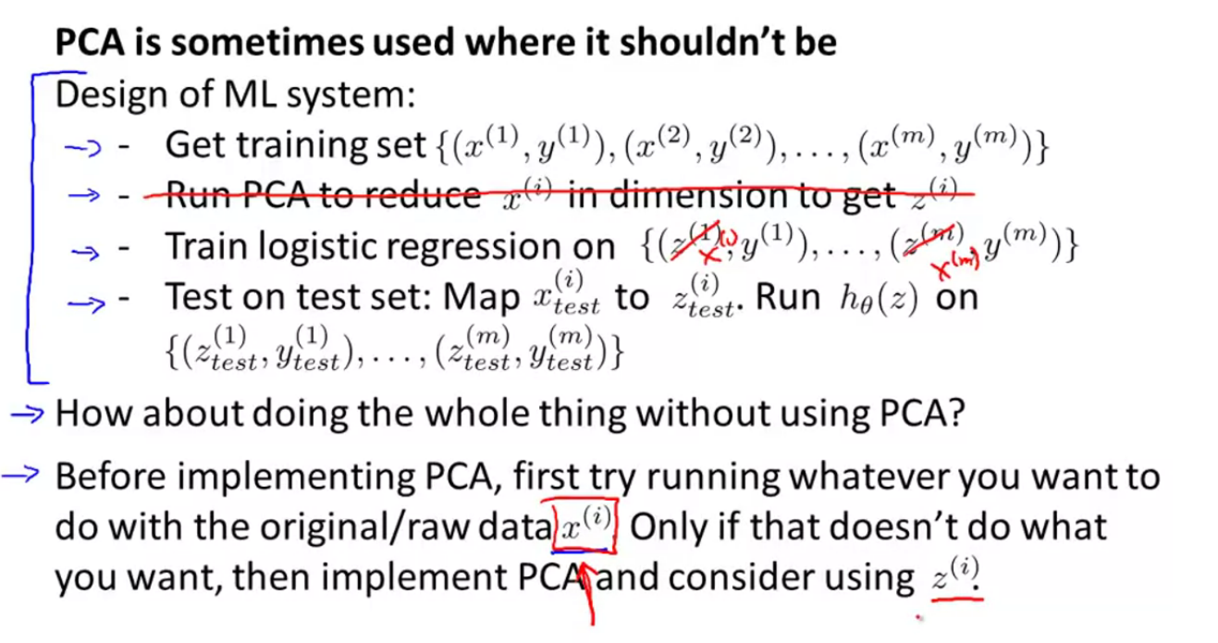

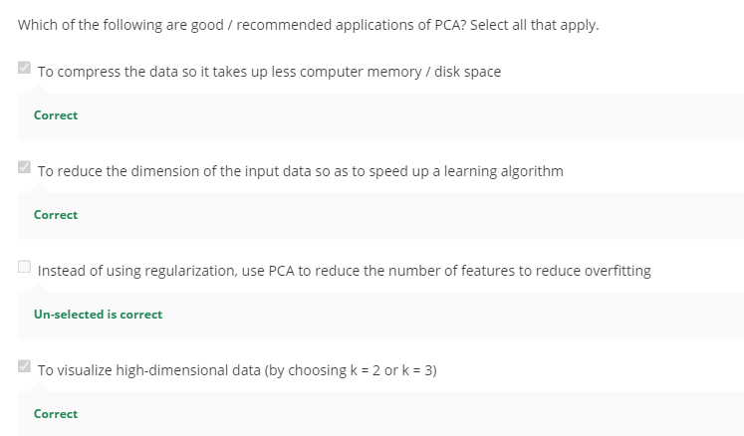

**ANOMALY DETECTION:**

